South East Technological University

Waterford



Semester 2: Project Implementation

Promotional Tool-Kit for a Musician

_________________________________________

Author: Supervisor:

Jake Dunphy O’Leary Brenda O’Neill

Student Number: 20101923

Course: BSc. in Creative Computing

Date: Thursday, April 16, 2026

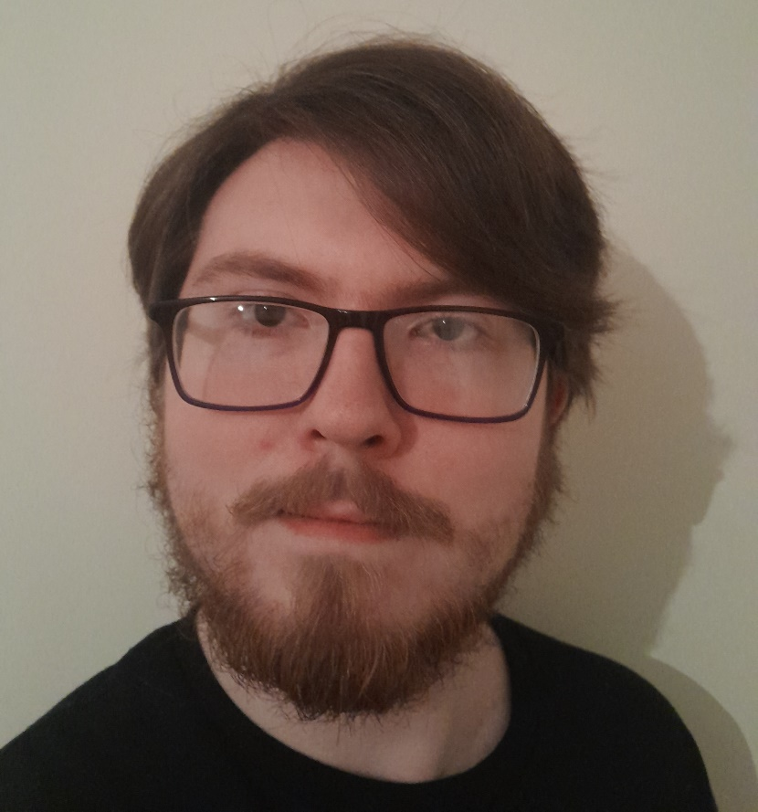
Figure 1: Jake Dunphy O'Leary

“Nothing really matters, but it matters if it matters to you”

Carly Rae Jepsen, Kollage (Jepsen, C.R., 2023)

South East Technological University, Waterford

Abstract
This project is a digital promotional tool-kit for an independent musician. It provides information, instructions and examples for an independent musician to use for their own releases. The project uses a selection of digital design programs and methodologies for each potential aspect of creation. Both physical and digital media are created for promotion. A manual is provided for the independent musician to follow.
The selection of digital artefacts created are:
- 3D Album Box;
- Album Box Art Design;
- CD Design;
- Poster Design;
- Promotional Video and Song Visualiser Video.

Methodologies for Graphic Design, 3D Modelling and Rendering and Video Production are used.

Types of software tested are open source and proprietary (free or paid) to provide options for use by an independent musician with no budget or with access to paid software.
This project creates User Guides as an aid to streamline the process for the independent musician as much as possible.

The project itself acts as a use case for others to follow and is grounded in practical application.

School of Science and Computing

Department of Computing and Mathematics

Course: BSc. In Creative Computing

4th year Project Semester 2

Promotional Tool-kit for a Musician

By

Jake Dunphy O’Leary

Declaration of Authorship

I, Jake Dunphy O’Leary, declare that this report titled, “Promotional Tool-Kit for a Musician” and the work presented in it are my own. I confirm that:

This work was done wholly or mainly while in candidature for an undergraduate degree at this University.

Where any part of this report has previously been submitted for a degree or any other qualification at this University or any other institution, this has been clearly stated.

Where I have quoted from the work of others, the source is always given. With the exception of such quotations, this report is entirely my own work.

I have acknowledged all main sources of help.

Where the report is based on work done by myself jointly with others, I have made clear exactly what was done by others and what I have contributed myself.

If AI was used, I have made clear why and how AI was used.

Signed:

Date:

Table of Figures
Figure 1: Mapping activity to software use 5
Figure 2: Adobe Product Logos (Proprietary and industry standard) 7
Figure 3 - Graphic Design Methodology (Kirpichnikov, 2025) 9
Figure 4 - 3D Modelling Methodology Diagram 1
Figure 5 - Modified 3D Modelling Diagram 1
Figure 6 - Video Production Pipeline Diagram [vmdigital, 2021] 1
Figure 7 - Production Timeline example 3
Figure 8 - Graphic Design Methodology (Reposted) 4
Figure 9 - 'NewJeans' EP Cover (NewJeans, 2022) 5
Figure 10 - 'Still With You' Single Cover (Jungkook, 2020) 5

Table of Tables
Table 1 Software Program Table 2
Table 3 - Hardware Specifications 4

Acknowledgements

Brenda O’Neill – Lecturer at SETU and Supervisor of Project.

Table of Contents
Abstract III
Declaration of Authorship V
Table of Figures VI
Table of Tables VII
Acknowledgements VIII
Table of Contents IX
CHAPTER 1: Introduction 1
1.1 Introduction 1
1.2 Description 2
1.3 Background 3
CHAPTER 2: Technologies 4
2.1 Hardware 4
2.2 Software 4
2.1.1 Open Source: 5
2.1.2 Proprietary/Industry Standard: 6
2.1.3 Proprietary (Free): 7
CHAPTER 3: Methodology Design 9
3.1 Choice of Methodology 9
3.2 Graphic Design Methodology 9
Design Brief: Step 1 10
Research Phase: Step 2 10
Concepts: Step 3 10
Concept Development: Step 4 10
Concept Feedback: Step 5 11
Polishing: Step 6 11
3.3 3D Modelling & Rendering Methodology (Modified) 1
Conceptualisation and Planning: Step 1 1
Blockout: Step 2 1
Modelling the Basic Shape: Step 3 1
UV Mapping: Step 4 1
Texturing: Step 5 2
Rendering: Step 6 2
3.4 Video Production & Rendering Methodology 1
Pre-Planning: Step 1 1
Pre-Production: Step 2 1
Production: Step 3 2
Post-Production: Step 4 2
Chapter 4: Development 3
4.1 Design and Development Schedule 3
4.2 Development by week 4
4.2.2 Week 1: 4
Digital Album Designs (Overview): 4
Use of the Graphic Design Methodology 5
4.2.3 Week 2: 6
4.2.4 Week 3: 6
4.2.5 Week 4: 8
Monthly Learning Outcome Review (January): 8
4.2.6 Reading Week: 8
4.2.7 Week 5: 9
4.2.8 Week 6: 9
4.2.9 Week 7: 10
References 11
‌Appendix A: 15
Schedule Checklist: 15
Appendix B: 16
Design Manual: 16
Album Logo (Proprietary – Affinity) 16
Digital Banner (Proprietary): 20
Artist Logo (Proprietary - Affinity): 21
Track List (Proprietary): 23
Album Design (Open Source - GIMP): 25
Digital Banner Design (Open Source – GIMP): 31
Artist Logo Design (Open Source – GIMP): 32
Track List Design (Open Source - GIMP): 33
‌ Poster Design (Proprietary - Affinity): 34
Poster Design (Open Source - GIMP): 36
Basic Album Box Model (Proprietary - MAYA): 37
Basic Poster Model (Proprietary – MAYA): 42
‌Basic Box Model (Open Source – Blender): 44
Poster Model (Open Source – MAYA): 46
Album Box Texture (Top – Proprietary): 48
Album Box Texture (Bottom – Proprietary): 51
Album Box Texture (Top – Open Source): 52
Album Box Texture (Bottom – Open Source): 54
T-Shirt Design (Proprietary): 54
T-Shirt Design (Open Source): 56
UV Mapping (Proprietary - MAYA): 58

CHAPTER 1: Introduction

1.1 Introduction
Design software, much like anything else in the world, comes in many different forms and styles. Often, people flock to the most popular or well-regarded software for their needs, but this does not always mean they are the best option.
In a world of ever-advancing technology, it is more important than ever to consider all options. In a historical context there is a danger to ‘the one best way’ of doing things. The first industrial revolution brought mass production at the end of the late 19th century and early 20th century. The concepts of Taylorism, time and motion studies and the factory model became ‘the one best way’ for a number of reasons. The main reason was that it was a profit driven model and at that time, with little or no regulation, was at the expense of human well- being. If we can learn anything from history then the selection of the ‘one best way’ closes off the consideration of other potentially viable options (Kanigel, 1999).
This is relevant in the context of this project where industry standard software is often used but is expensive. In companies or institutions where licenses are provided for use by the employees the cost is not a consideration but for independent creators of content the cost is a primary consideration and can be a limiting factor. This project, by providing a window on open source/free alternatives to proprietary software provides choice to the independent musician so that cost is not an inhibiting factor to the creation of promotional material.
This project exists both as a baseline and as a demonstration. It shows creatives that, while the first hurdle (software selection) may be the most daunting, it is certainly not impossible to cross. Whether constraints are because of low/no budget, lack of powerful hardware, or simply a lack of technical knowledge, there are options for software to suit diverse needs.
The goal for this project is for it to provide an example and aid for those wishing to start in digital creation, either as a hobby or as a potential career option. The use case is that of promotion for an independent musician.
Chapter one has given the background to this project by providing a historical context to ‘the one best way’ and illustrating the importance of the consideration of other options. Chapter two provides an overview of the project by taking a ‘deep dive’ into it.

1.2 Description
This project entails the creation of a number of promotional materials for a musician to use to promote his/her musical projects. It includes:
- Album box art (front, back and sides)
- A digital cover for streaming services
- An artist logo and banner (for use on social media and streaming sites)
- A CD design
- A promotional poster
- A track list poster
- Merchandise designs (t-shirts, hoodies and stickers are what will be made for this project).
The following software(s) that this project investigates are:
Table 1 Software Program Table
SOFTWARE
ACTIVITY | Industry Standard Software | Proprietary Software | Open-Source Software
Photo Editing | Adobe Photoshop | Affinity Photo | GIMP
Vector Graphics | Adobe Illustrator | Affinity Designer | Inkscape
3D Modelling/Rendering | Maya | ZBrush | Blender
Video Editing | Adobe Premiere Pro | Magix Vegas | Kdenlive
Digital Motion Graphics | Adobe After Effects | DaVinci Resolve | Friction

1.3 Background
The inspiration for this project comes from various musicians and the different design languages they use to express their craft. Visual design has an inherent relationship with music and this project aims to show and detail that connection and make it easier for the musician to develop their own design language for their musical projects.
The plan is to utilise design software that covers different segments of digital creation (Video Editing, Photo Editing, Vector Graphics), sorted by release types (Industry Standard/ Proprietary/Open Source). These programs are then used to create, design and promote a music album by the creation of relevant materials (merchandise, posters). The process of creating these materials is comprehensively documented using various types of software. The experience and knowledge gained whilst using them culminates in a practical and comprehensive user manual.
This project and subsequent documentation looks at digital creation from a person-first lens. It is important to shine a critical lens on the tools and concepts that are the current most popular, to see why they are successful, and perhaps see where they hold flaws. This document looks to give aspiring creative artists a look at the vast options that digital creation holds as spoken about previously in chapter one.
This document is also mindful of budget constraints, or a lack thereof. Creative artists with a larger budget can afford subscriptions to the products with the largest budget and developer base, while those in poorer countries or difficult financial situations can turn to the fellow independent creative communities that make their own software.

CHAPTER 2: Technologies

2.1 Hardware
This project uses two different devices, a higher budget desktop and a lower budget office laptop.

HARDWARE SPECIFICATION
FEATURES | LOWER BUDGET (LAPTOP) | HIGHER BUDGET (DESKTOP)
Make/Model | Avita Liber V
Motherboard |  | MSI PRO H610M-E DDR4 (MS-7D48) 2.0
RAM | 8 GB DDR4 | 16GB DDR4
CPU | AMD Ryzen 5 3500U | Intel Core i5 12400F
GPU | Radeon Vega 8 Graphics | NVIDIA RTX 3060 12GB
Storage | 250GB SSD | 1TB SSD
Operating System | Windows 10 LTSC | Windows 10 LTSC
Table 3 - Hardware Specifications

2.2 Software
The following diagram represents the activities that a creative artist engages in and the potential software for these activities. They are colour coded based on the type of software for easy identification.

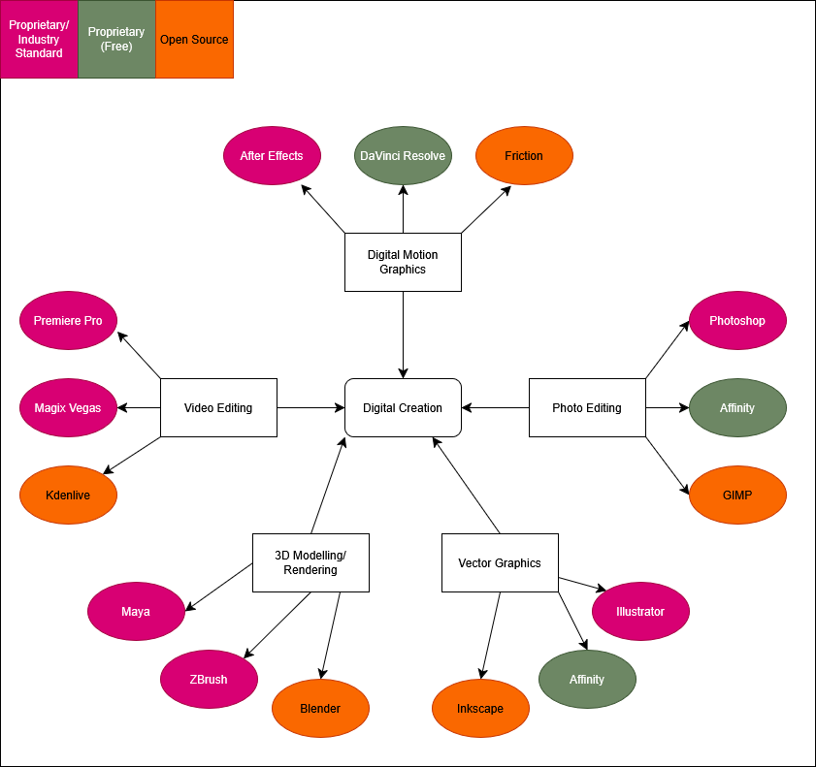
Figure 2: Mapping activity to software use
It is important to have a clear understanding of what open source, proprietary and free mean.

2.1.1 Open Source:
Open source, in relation to software, refers to software where the owner and creator allows others to freely use, inspect, and modify its source code. This encourages open collaboration and community between both users and developers. Open-source software is typically free, but this is not guaranteed. Open-source software is typically created for a multitude of reasons. This includes:
- Fulfilling an untapped niche.
- To provide a lower cost alternative to an existing proprietary program.
- For a developer to practice development with a low-stakes project.
- There are many other reasons for Open-source software to be created, but these are some of the more common origins. Not for profit.
- Open-source does not necessarily mean it is made independently or without a team structure. Two examples of project team structures are detailed by Ben Balter.
- Balter describes the Cathedral and Bazaar people management styles. These management styles are also discussed in the Richard Sennet book, ‘The Craftsman’. (Sennet, 2008)
- The Cathedral style works top-down using a focused vision and goals, led by a manager. It provides clarity and a sense of stability, but can feel rigid and like a hierarchy. Poor management is felt deeply in this style.
- The Bazaar style works more broadly and without specific, detailed goals. The manager acts like a guide or a coach for the team, rather than a leader. This style promotes innovation and openness, but can lead to confusion and aimlessness if poorly managed.

2.1.2 Proprietary/Industry Standard:

Proprietary software is software that is only available to its creators, typically a company, that is the software’s sole developer and distributor. Proprietary software can also be described as “for profit” software, existing with the intention of selling to a large consumer base.
Proprietary software often takes less risks or experimentation compared to open-source software, and have tightly held licenses and source code that are rarely, if ever, released to the public willingly. Software is made proprietary for various reasons, such as:
- Preventing competing companies from using their source code as a baseline.
- Preventing users from freely modifying and changing code, therefore requiring reliance on the owners.
- Allowing for tightly locked license distribution, making piracy more difficult.
- Making security updates more secure due to a lack of freely available code.

Proprietary software is often developed by much bigger and more experienced teams, with a focused vision in mind. This leads proprietary software to come across as more professional and solid compared to open-source software. This comes at a literal cost, as well as the cost of transparency and communal development. It is usually commercial.
A good example of commercial design products is the Adobe suite. Adobe creates and manages a large variety of design programs, a selection of which this document looks at in more detail.
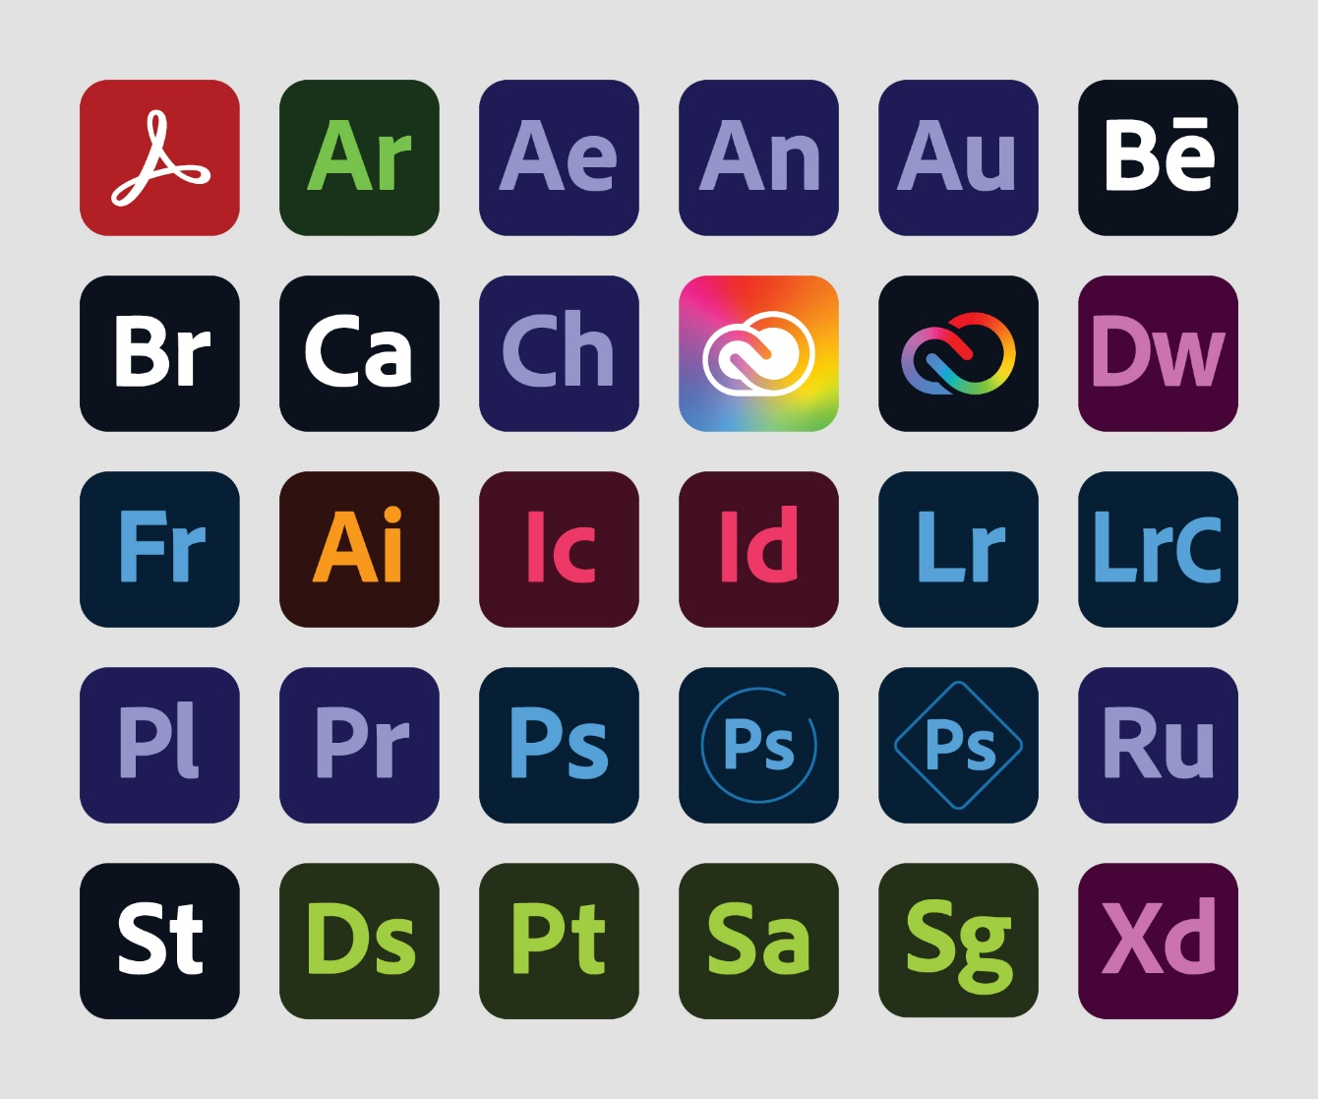
Figure 3: Adobe Product Logos (Proprietary and industry standard)

2.1.3 Proprietary (Free):

Some proprietary software is made free to use by its owners. This is usually done by a corporation who are not making enough profit by putting their product behind a paywall. Corporations must have some alternative way to still make a profit when their products are released for free. This often comes in the form of advertisements built into the program itself. Sometimes it is done when a corporation makes enough of a profit by other means that they can afford to release one of their products for free.
Affinity Photo and Affinity Design, originally a collection of proprietary programs owned by Canva, were combined into one free program earlier this year, whilst this document was being written. A statement from Canva themselves state that they were a stable enough company to release Affinity for free (Hewson, 2025).

CHAPTER 3: Methodology Design

3.1 Choice of Methodology
This document does not use one singular methodology throughout, such as Agile or Waterfall. The reason for this is that design and artistic projects are not as rigid and measurable as a software development project. For this reason, each major creation aspect this document covers will use its own methodology, decided on through analysing the most common method used by professionals.

3.2 Graphic Design Methodology
This document lays out a 6-step process for the Graphic Design aspect. This methodology is documented by Ihor Kirpichnikov (Kirpichnikov, 2025), and Jessica Barker of Brafton (Barker, 2025).

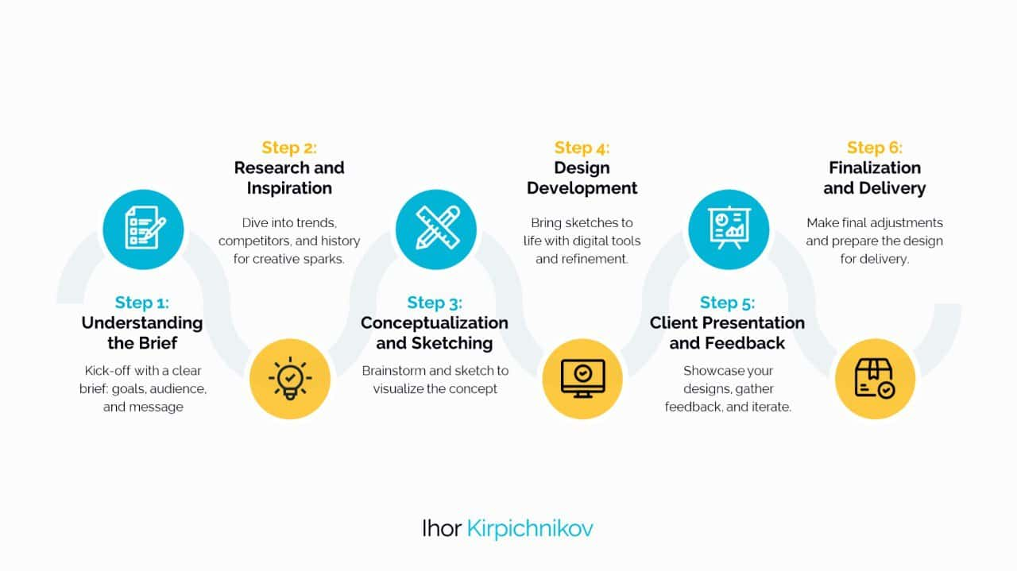
Figure 4 - Graphic Design Methodology (Kirpichnikov, 2025)

The steps are as follows:

Design Brief: Step 1
This step is where the aims of the design are pre-defined. This can involve detailing a design language, what style to achieve, what formats and canvas sizes will be used, what the design is for, etc.
This step is where the basis of the project is laid out.
For example, when designing a CD Cover, you need to consider how large a CD is, how to print the cover onto a real CD, and what style the CD will have.

Research Phase: Step 2
This step involves looking at other designs and research to understand best practise in graphic design. The point of this step is to get a clearer vision of what to achieve with the design, and how to make sure it looks professional and clean.
Since this project involves creating promotional materials, this step involves looking at other album covers, physical album boxes, various pieces of merchandise, song visualisers. This allows the designer to identify what they do and do not like in order to have a better understanding for this and future projects.

Concepts: Step 3
This step involves brainstorming designs. This includes inspirations, colours, emotions, moods, images, layouts.
The ideas and concepts thought up in this step become the basis for the full design. This step is also why it is best to do the graphic design first, as it influences the design theme for the rest of the project.
It is here that it is best to have a description of what is being created, and what the design is meant to invoke in the viewer.

Concept Development: Step 4
This step is where you experiment and plot out the ideas initialised in the previous step. This includes making mock-ups, experimenting with colour palettes, testing fonts, etc.
For example, on a CD cover, decide if the text should go on the sides or on the top or bottom. Look at the colour wheel and decide what colours mix well together. This is also a good place to practice using the chosen design programs.

Concept Feedback: Step 5
This step involves showing the conceptualised designs to others to get outside opinions and feedback. This can be done formally through surveys, or informally through word of mouth. This feedback is then used in the final step.
This can be done through A-B Testing (showing two different designs and asking others to choose which they prefer) or through simple surveys.

Polishing: Step 6
This step is simple. Take the feedback and opinions received in the previous step, and use them to polish and perfect the final designs. These last two steps can be repeated until satisfied with the final product. This step may take the longest time depending the vision and scope of the project.

3.3 3D Modelling & Rendering Methodology (Modified)
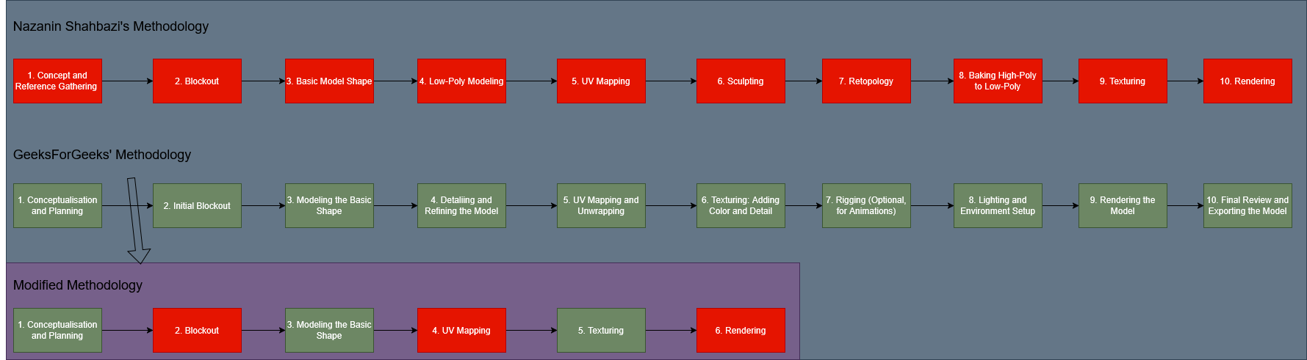
Figure 5 - 3D Modelling Methodology Diagram

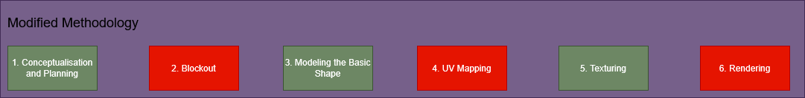
Figure 6 - Modified 3D Modelling Diagram

This next stage is a 6-step methodology derived and slightly modified from two similar processes laid out by Nazanin Shahbazi of Pixune (Shahbazi, 2024), and GeeksForGeeks (GeeksForGeeks, 2025). These processes contain steps for other 3D sectors, such as games assets and animation, which are not relevant to this project.

Conceptualisation and Planning: Step 1
This is where you determine what the model will be, and its purpose. It is best to look at references and other ideas to get a clearer vision of what to achieve. It is also recommended to draw a concept sketch to look at.
For example, if making a physical CD box for an album, determine how it should be shaped, and what it is being used for. Is it an example to show others or a digitised version of a real object? This is important to determine before starting the model.

Blockout: Step 2
This step is where the modelling itself begins. In this step, use very simple shapes to create the big picture of the model. Stick with cubes, spheres, cylinders and cones for this step.
For example, when making an album box, block out basic thin cuboids. If the box is open, align the cuboids diagonally. You should prioritise the concept of the shape, rather than trying to form it into a more detailed object.

Modelling the Basic Shape: Step 3
In this step, take the blocked out shapes created and refine the proportions and geometry.
For a geometric object like an album box, this step is simple. For example, take the inside of the cuboid and indent it so that objects could fit inside of it, much like a real box.

UV Mapping: Step 4
UV Mapping is the process of taking a 3D model and turning it into a flat 2D object. This is done for the purpose of making sure textures line up with the model correctly.
In the example provided, this would be fairly straightforward. An album box would be made of squares and rectangles of various sizes, so very little work would need to be done.

Texturing: Step 5
The next step is texturing, where a visual identity is given to the model. Various types of texture maps are applied to invoke colours, surface detail, reflections or shine, roughness, patterns, and simulated geometry.
In the album box example, this is the step where you make the box look more like a physical album rather than a generic cuboid shape.

Rendering: Step 6
Rendering is the process of taking the finished model and putting it into a suitable scene, such as under virtual lights with a designated and modified virtual camera. This is done to put the model on display in a way that will appeal to a viewer, making the model itself look more professional and cleaner.
For the album box, this could be done by sitting the box partially open with a strong fill light, to show both the outside and inside of the box and its textures clearly.

3.4 Video Production & Rendering Methodology
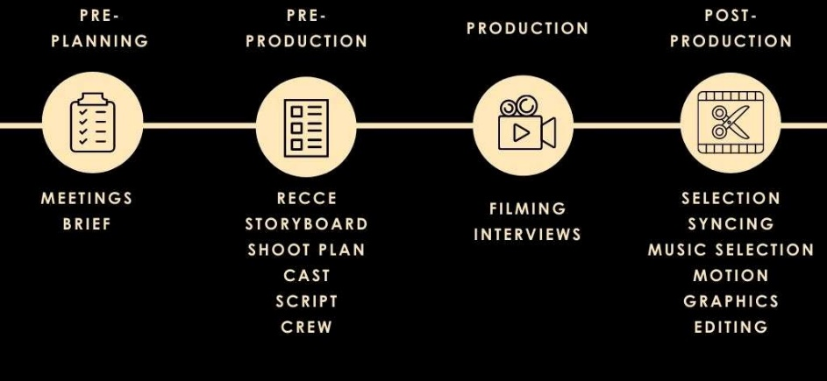
Figure 7 - Video Production Pipeline Diagram [vmdigital, 2021]

This 4-step methodology used for Video Production and Rendering is based off of articles by Fiona Marsh of VMDigital (Marsh, 2021), and Jacob Trussell of Mountain.com (Trussell, 2025).

Pre-Planning: Step 1
This step involves planning and deciding on what the video project will be. This is where the purpose of the video is established, what level of budget is available, whether or not a voice over is required, what the target audience is, what is to be conveyed, and where the video will be released and promoted.
For example, if making a promotional video for a new album, it is best to include graphics showing the cover of the album and its design. A voice-over might not be necessary, instead a snippet of a track from the album could be used instead. In the case of this project, it is presumed the budget will be low or even non-existent, and the target audience may be the general public or a particular niche of music listeners.

Pre-Production: Step 2
For a video shot in person, this step would involve getting a cast together, organising shoots, creating a script, and deciding on a site. For a digital video, this step can instead involve gathering assets, making storyboards or animatics, and making a rudimentary version of the final video.
For the example of an album promotion, either method could be used, but for the purpose of sticking to a budget-friendly document, and to keep in line with the previous methodologies, it is presumed the project will be made entirely digitally. It is best to have a 3D model and album cover design finished by this point to use for any promotional videos.

Production: Step 3
This is where the video itself will be made. For real-life footage, this is the step where the footage itself is recorded and formatted for various screen sizes and social medias. For digitally created footage, this is where the scenes are made, usually in a 3D program and exported as an animated video.
For the album promotion example, a digitally created object and scene can be made in a chosen 3D Modelling and Rendering program, and created using basic animation and camera movements. At this stage of the process, nothing but video footage would be created.

Post-Production: Step 4
This is where the real life and digital footages converge and follow the same process. This step involves taking recorded footage, whether filmed or generated, and putting it into a polished video. Adding text, music, colour grading, cutting and splicing footage, and polishing it into a finished project.
For the Album promotion example, this is where the created renders of the 3D objects would be put into a video editing and/or Digital Motion Graphics software and put together into a finished video.

Chapter 4: Development

4.1 Design and Development Schedule

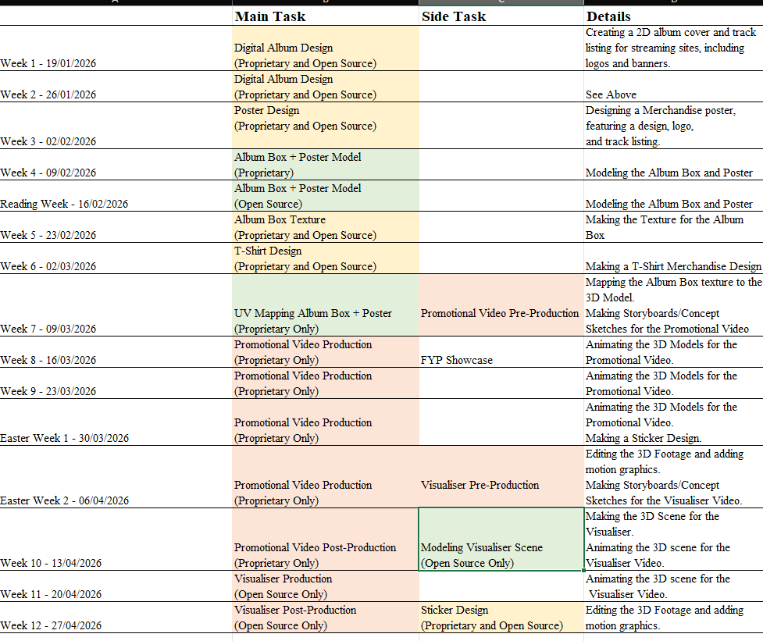
Figure 8 - Production Timeline example
A simple schedule of production for a typical university semester has been created in Microsoft Excel. The 3D Modelling does not begin until after most of the Graphic Design has been done, as the graphic design assets are needed for the 3D Modelling. The same logic is used for the Video Production. More time has been allocated for the Video Production than the other aspects, as this aspect is more time-consuming and difficult. The Promotional Video and Visualiser have each been assigned one of the two between Proprietary and Open Source. This is because these two assets will demonstrate mostly the same skill set, and their time-consuming nature means that making the same assets twice will be too much for the timeline provided.
This timeline was heavily modified during Reading Week. In order to adjust for assignment due dates, simpler assets have been allocated to Weeks 5 and 6 to allow time for work on other projects. Due to worries about Texture Mapping Issues and a steep learning curve, the Promotional Video and Visualiser have swapped Software, with slightly more time now allocated to the Visualiser.

4.2 Development by week

4.2.2 Week 1:
Weeks 1 and 2 were spent creating digital promotional materials for the album. This kind of promotional material are used on streaming sites such as Spotify (Spotify, n.d.), Apple Music (Apple Music, n.d.) and Soundcloud (Soundcloud, n.d.). The items created were
- a box size cover;
- a banner;
- an artist logo;
- a track list infographic.

Digital Album Designs (Overview):
The following materials use the Graphic Design Methodology.
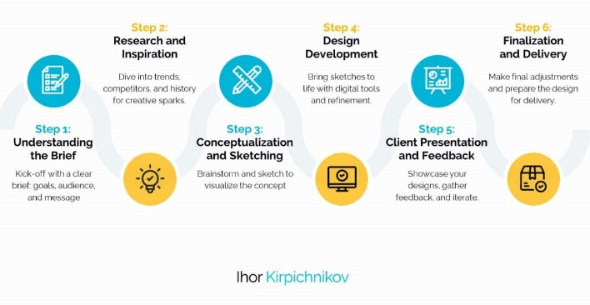
Figure 9 - Graphic Design Methodology (Reposted)
The brief for these materials was as follows:
Brief: A set of graphics that can be used for social media profiles and streaming sites, such as Soundcloud (Soundcloud, n.d.), YouTube (YouTube, n.d.), Deezer (Deezer, n.d.), Instagram (Instagram, n.d.), and more.

The intent is that the design matches/harmonises with the CD Cover Design created previously in Semester 1, so that the colour palette and fonts chosen provide consistency.
The inspiration/research for these designs comes primarily from Korean Pop Music, which tends to use purely graphical designs for album covers, rather than using photographs.
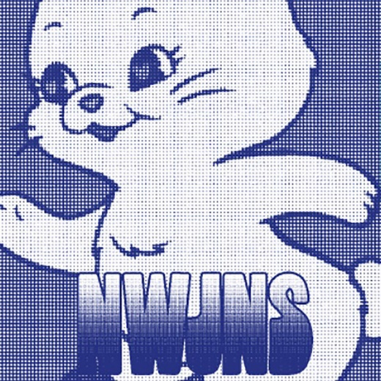
Figure 10 - 'NewJeans' EP Cover (NewJeans, 2022)
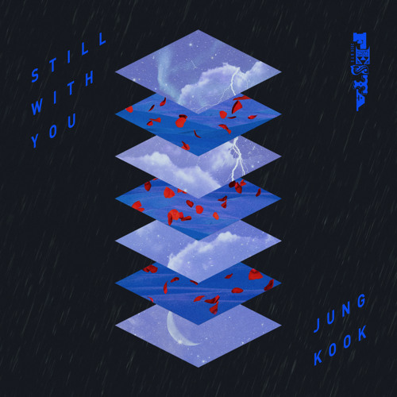
Figure 11 - 'Still With You' Single Cover (Jungkook, 2020)

Use of the Graphic Design Methodology
The Conceptualization phase involved looking at the typical image sizes expected for certain graphics e.g., Soundcloud recommends an image of 2480x520px for banners.
The Design and Development phase is covered in more detail below. This is where the design software in question is used to execute the proper designs.
The Feedback phase is less formal, since this project is likely to be a passion project rather than a commercial one. Asking friends and family for input on designs may not elicit much useful advice, unless those you are asking also have a passion/skill in Graphic Design.
The Finalization and Delivery phase typically happens by the end of the week, but the designs are still fluid until the end of the established timeline, which is Week 12 in the schedule provided above.
A detailed description of the creation of the artefact using both proprietary software and open source software is in the Appendix.

Reflection: After experiencing the time required in the initial development during week one and week two it was deemed appropriate to create the artefacts in proprietary software and open source/free software where practically possible with a strong emphasis placed on the avoidance of any unnecessary duplication in order to stay within the academic time constraint. This may lead to a subset of the artefacts being created in both proprietary and opensource/free software to provide a complete example to the user and the remainder being created in either).

4.2.3 Week 2:
Week 2 is a continuation of the Digital Album Assets from Week 1, but recreated in Open-Source software. The intent is to make the exact same designs where possible. Some alternatives are taken where certain effects or shapes could not be recreated exactly e.g. the Star shape which was created in Inkscape rather than using a specified tool in Affinity.

Methodology: The methodology used is the Graphic Design Methodology explained in Section 3.2.

Reflection: The Open-Source version of this asset was a little bit more difficult to make, and the lack of simple tools in Inkscape/GIMP is felt harshly.

4.2.4 Week 3:

Poster Design (Overview):
The poster size chosen is 18x24 Inches. This size was chosen as a middle ground between a concert sized poster, and a small poster.
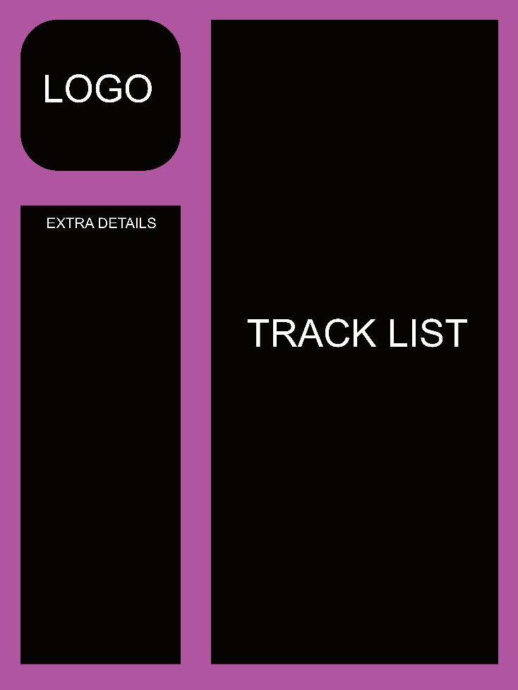
Figure 12 - Poster Layout
This is the mock-up poster, a very simple layout of where each element will be placed. The mock-up was made in Affinity, but can be easily recreated in any software. This mock-up will be used (in tandem with the digital Track List Design) to create the poster. A detailed description of creation of the artefact can be seen in the Appendix.

Use of the Graphic Design Methodology (Modified)
The Methodology used was the Graphic Design Methodology as followed in Weeks 1 and 2. A slight modification has been made, which is making a mock up design as part of Step 3, Conceptualisation. This was done to plan out the layout more easily. This is considered under Step 3 as this is the phase where the idea is slowly materialised in its infancy.

Reflection: The Poster design was simpler to make than the previous assets. This is because the Digital Album assets were repurposed and reused for the Poster, simplifying the process greatly. This is common practise by artists/record labels to save costs and time, so it is a practice this project uses often.

4.2.5 Week 4:

Album Box + Poster Model (Proprietary) – Overview:
Week 4 involved the creation of the Album Box and Poster models in Maya. Originally, both the Proprietary and Open Source models (in Blender) would be made and UV Mapped this week, but due to difficulties surrounding university assignments this was rearranged.

Methodology: This asset used the modified 3D Modeling and Rendering Methodology explained in Section 3.3.
Reflection: Thanks to past experience using Maya, this model was not too difficult to make, although it was the most complex asset to make thus far as it involved adding flaps to a basic Cube in the software, which I could not find a streamlined method for doing.

Monthly Learning Outcome Review (January):
Info learned/to keep in mind for the future. | - It’s important to keep constant track of progress, especially while creating assets, to avoid forgotten information or mistakes.  - It’s important to keep the methodology in mind while working with assets.
Developed Opinions | - I’ve personally found Affinity much easier to grasp compared to GIMP and Inkscape.

4.2.6 Reading Week:

Album Box + Poster Model (Open Source) – Overview:
This week, the Album Box and Poster models were made in the Open-Source software Blender. A large change to the asset schedule was also made this week to try and give as much time as possible for other projects during the semester.

Methodology: This asset used the modified 3D Modeling and Rendering Methodology explained in Section 3.3.

Reflection: This asset was much more difficult to make than anticipated. Some experimentation with Blender (A software I had never used prior to this project) revealed that animation in the software works very differently to Maya. Because of this, I rearranged the schedule to give as much time as possible to make the Promotional Video, to give time to learn Blender.

4.2.7 Week 5:

Album Box Texture (Overview):
This week involved making the texture for the Album Box Model. This was done in both Proprietary and Open-Source software (Affinity and GIMP), although only the Open-Source version will be used in later assets.

Methodology: This asset used the Graphic Design Methodology explained in Section 3.2.
Reflection: This asset was very simple to make as previous assets were reused to make the texture. UV Mapping will be done later in the semester, and some difficulties with how the texture was created may arise.

4.2.8 Week 6:

T-Shirt Design (Overview):
This week involved making a T-Shirt Merchandise design. This was done in both Proprietary and Open Source software (Affinity and GIMP). The intention is to make a design that could be sold in theory.

Methodology: This asset used the Graphic Design Methodology explained in Section 3.2.

Reflection: Thanks to the reusage of previously made assets, this asset was simple to make. This was placed on week 6 to give more time for other University projects.

4.2.9 Week 7:

UV Mapping (Overview):
This week involved mapping the Album Box and Poster textures (Proprietary) to the Album Box and Poster models in Maya, as well as making, as well as making simple storyboards for the promotional video.

Methodology: This asset used the 3D Modeling and Rendering Methodology explained in Section 3.3.

Reflection: A large number of issues sprung up during the creation of this asset. Firstly, the way the album box was modelled meant that mapping the texture was effectively impossible, due to a large number of added lines that shouldn’t be there in the model. I could not find any way to fix this manually, so the box was remade in a simpler form with the irrelevant sides deleted. The texture was successfully mapped to this modified version of the box model. This was done in Maya as it was the software I was more familiar with in terms of texture mapping.
Due to concerns that I wouldn’t have enough time to figure out how to do this in Blender, especially since the Album Box model made in that software has a similar issue, I have chosen to only UV Map the model in MAYA and to do the Promotional Video in Proprietary software instead of the Visualiser.

Promotional Video Pre-Production (Overview):
The Promotional Video assets were drawn digitally on a mobile phone using the app Infinite Painter. This is not a part of the overall software framework, so no Open Source alternative has been sourced.

Methodology: This asset used the Video Pipeline Methodology explained in Section 3.4.

Reflection: These storyboards are very simple in nature and are not very refined, as storyboards are more of a rough concept of how the video should look, rather than a completed product. Perhaps more panels could have been made for clarity, but it gets the general concept across.
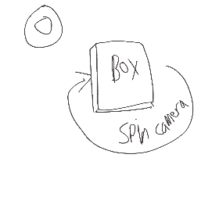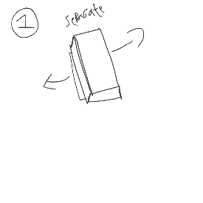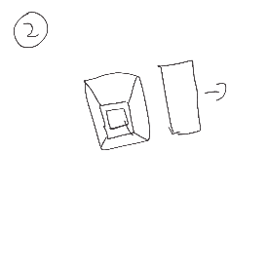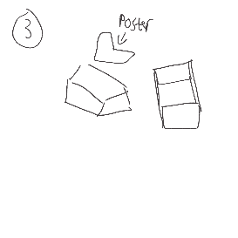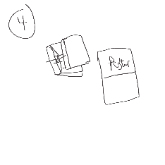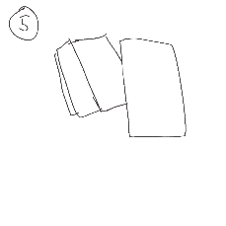
Figure 13 – Promotional Video Storyboard Sequence

4.2.9 Weeks 8 to Easter Week 2:

Promotional Video Production (Overview):
The following weeks involved creating the base footage for the Promotional Video in MAYA.

Methodology: This asset used the 3D Modeling and Rendering Methodology explained in Section 3.3.

Reflection: This asset was difficult to make for a multitude of reasons.
Firstly, the UV Mapping done in Week 7 turned out to be an incorrect method that caused a large number of issues when trying to turn and move the objects. This step had to be completely redone. This led to this asset needing an extension in the timeline (hence why there are four weeks allocated to it in the above schedule).
Secondly, the creation of this asset coincided with the creation of a Final Year Project poster. This asset is relevant to this project, but not this document, so it will not be detailed here. This caused further delays in making this asset. The similar asset to be made in Week 11 will not be as difficult as it does not involve UV Mapping and will be using simpler shapes. There may still be some difficulties as I have much less experience with Blender, Kden and Friction (none used before this project) compared to MAYA (used in University), Magix Vegas (used personally) and After Effects (never used).
The export of the MAYA scene took much longer than expected (4 hours for roughly 15 seconds of footage), so the Visualiser will have to be a condensed example (roughly 40 seconds).

Visualiser Video Pre-Production (Overview):
The Pre-production for the Visualiser Video was also made this week.

Methodology: This asset used the 3D Modeling and Rendering Methodology explained in Section 3.3.

Reflection: These storyboards were drawn in Infinite Painter, same as the previous storyboards. These were short to make, as it’s hard to make storyboards for a simple scene that properly conveys what the video will be (A first-person view of driving through a city, as if the viewer is in a car).
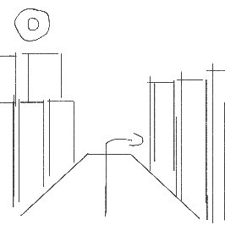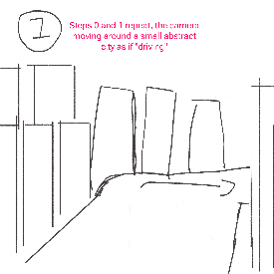
Figure 14 - Visualiser Video Storyboard Sequence

References
Balter, B. (2023). Cathedral vs Bazaar People Management. [online] Ben Balter. Available at: https://ben.balter.com/2023/12/08/cathedral-bazaar-management/ [Accessed 3rd Nov. 2025].
Barker, J. (2021). This 6-Step Graphic Design Process Drives Results (Infographic). [online] Brafton. Available at: https://www.brafton.com/blog/graphics/graphic-design-process/. [Accessed 25th Nov. 2025]
Blake, H. (2025). Cost-Benefit Analysis Proprietary Licensing Vs. Open Source Economics. [online] ResearchGate. Available at: https://www.researchgate.net/publication/392557896_Cost-Benefit_Analysis_Proprietary_Licensing_Vs_Open_Source_Economics. [Accessed 18th Nov. 2025]

Jepsen, C.R., Berger, P. 2023. Kollage. Carly Rae Jepsen. The Loveliest Time. [Digital Audio]. United States: 604, Schoolboy, Interscope Records.
GeeksforGeeks (2025). 3D Modeling Process: A Step by Step Guide. [online] GeeksforGeeks. Available at: https://www.geeksforgeeks.org/blogs/3d-modeling-process-steps/. [Accessed 25th Nov. 2025]
Grupo Erik Editores S.L. (2025). Europosters.ie [online] Available at: https://www.europosters.ie/posters/aespa-supernova-v184428 [Accessed 8th Dec. 2025]
Hewson, A. (2025). Introducing the all-new Affinity: Professional design, now free for everyone. [online] Available at: https://www.canva.com/newsroom/news/all-new-affinity/. [Accessed 2nd Dec. 2025]
Hoffmann, M., Nagle, F. and Zhou, Y. (2024). The Value of Open Source Software. SSRN Electronic Journal. [online] https://doi.org/10.2139/ssrn.4693148. [Accessed 18th Nov. 2025]
HYBE LABELS (2025). LE SSERAFIM (르세라핌) 'DIFFERENT (English ver.)' Official Visualizer. Available at: https://youtu.be/NezdSLx4O7w [Accessed 8th Dec. 2025].
JYP Entertainment (2025). NMIXX(엔믹스) “Blue Valentine” Trailer: The Paradox of Love. Available at: https://youtu.be/QSvlQxjnQaQ [Accessed 8th Dec. 2025].
Kirpichnikov, I. (2024). 6-step Graphic Design Process: From Concept to Completion. [online] The best of AI and online business in one place. Available at: https://www.ikagency.com/graphic-design-typography/graphic-design-process/. [Accessed 25th Nov. 2025]
Koreaboo. (2017). Koreaboo. [online] Available at: https://www.koreaboo.com/stories/11-kpop-albums-best-packaging/ [Accessed 2nd Dec. 2025].
Marsh, F. (2021). What are the 4 stages of video production - VM Digital. [online] Available at: https://vmdigital.ie/stages-of-video-production/. [Accessed 2nd Dec. 25]
Pragunagarwal.com. (2025). Filament — Pragun Agarwal — Portfolio. [online] Available at: https://pragunagarwal.com/Filament [Accessed 2nd Dec. 25].
Sennett, R. (2008). The Craftsman. Penguin UK.
Shahbazi, N. (2024). 10 Main Steps in 3D Modelling Process. [online] Available at: https://pixune.com/blog/3d-modeling-process/. [Accessed 25th Nov. 2025]
tasty design (2025). Music T-shirt design. Music t-shirt design vector. For t-shirt print and other uses. [online] Vecteezy. Available at: https://www.vecteezy.com/vector-art/11426982-music-t-shirt-design-music-t-shirt-design-vector-for-t-shirt-print-and-other-uses [Accessed 8th Dec. 2025].
Trussell, J. (2025). Video Production Process: Complete Guide for 2025 - QuickFrame. [online] QuickFrame. Available at: https://quickframe.mountain.com/blog/video-production-process/. [Accessed 2nd Dec. 2025]
University, D. of I.T.H., Ave, 400 S.O., South Orange, N. 07079 and (973) 275-2222 (n.d.). Adobe Creative Campus - Seton Hall University. [online] www.shu.edu. Available at: https://www.shu.edu/technology/adobe.html. [Accessed 18th Nov. 2025]
Vasconcellos, R. (2007). Wikimedia. [online] Available at: https://commons.wikimedia.org/wiki/File:Jewel_Case_02.jpg [Accessed 8th Dec. 2025].
Wikipedia. (2021). Optical disc packaging. [online] Available at: https://en.wikipedia.org/wiki/Optical_disc_packaging. [Accessed 2nd Dec. 2025]

Kanigel, R. (1999). The one best way : Frederick Winslow Taylor and the enigma of efficiency. New York: Penguin Books.

Sennett, R. (2008). The craftsman. [online] New Haven, Conn. Yale University Press. Available at: https://nyuscholars.nyu.edu/en/publications/the-craftsman.

Spotify (n.d.). Spotify. [online] Spotify. Available at: https://open.spotify.com/. [Accessed 12th Feb. 2026]

Apple Music. (n.d.). Get millions of songs. All ad-free. [online] Available at: https://music.apple.com. [Accessed 12th Feb. 2026]
‌
Soundcloud (n.d.). SoundCloud – Listen to free music and podcasts on SoundCloud. [online] SoundCloud. Available at: https://soundcloud.com/. [Accessed 12th Feb. 2026]

YouTube. (n.d.). YouTube. Available at: https://www.youtube.com/. [Accessed 12th Feb. 2026]
‌
Deezer. (n.d.). Deezer | Listen to music | Online music streaming platform. [online] Available at: https://www.deezer.com. [Accessed 12th Feb. 2026]

Instagram (n.d.). Instagram. [online] Instagram. Available at: https://www.instagram.com. [Accessed 12th Feb. 2026]
‌
NewJeans (2022) 'New Jeans’. Available at: https://open.spotify.com/album/1HMLpmZAnNyl9pxvOnTovV [Accessed 12th Feb. 2026]

Jungkook (2020) ‘Still With You’. Available at: https://on.soundcloud.com/aVqQqmkoM8oqgPIVJm [Accessed 12th Feb. 2026]
‌

‌Appendix A:

Schedule Checklist:
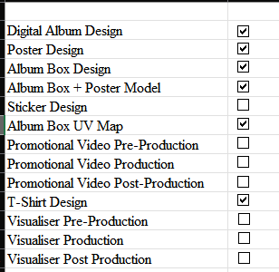
Figure 15 - Schedule Checklist
‌

Appendix B:

Design Manual:

Album Logo (Proprietary – Affinity)
Make a 5000x5000 Canvas in Affinity. Add a Pixel layer for the background and make a gradient with the following values.
- RGB(18,38,57) at 0% position.
- RGB(46,63,153) at 25% position.
- RGB(107,57,27) at 75% position.
- RGB(184,102,165) at 100% position.
Drag this gradient from bottom right to top left.

Create a text frame across the middle of the canvas, with the font “Engebrechtre”. This font is a free-to-use commercial font, which can be found on the site “DaFont”. Set the font type to Italic. Make the text centred and change the size to 288 points. Align the text box with the centre of the canvas. Change the colour to RGB (178,242,255).
Open Layer Effects for the text layer. Enable Outer Shadow. Use the following settings, and set the colour to RGB (255,15,255).
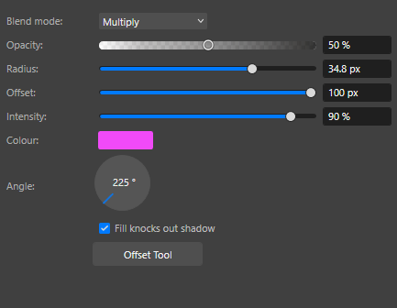
Figure 16 - Proprietary Digital Cover Step 1
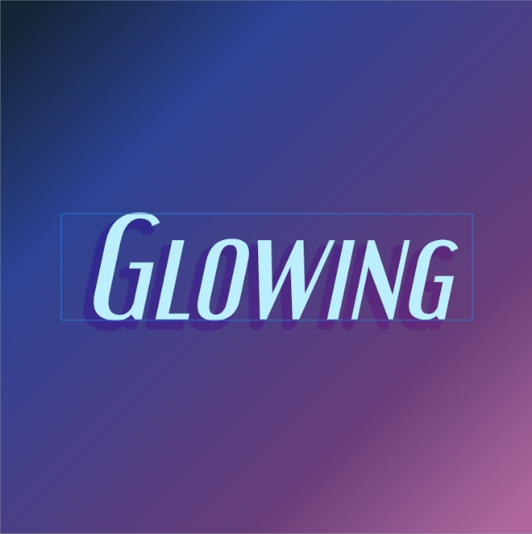
Figure 17 - Proprietary Digital Cover Step 2

These are the results so far. The blue rectangle is the text box shown by Affinity, and is not a part of the final design.
Duplicate the text layer and move it to the top of the canvas (but do not have the text touching the top). Change the text to the artist name and set the size to 48px. Adjust the text as needed. Go to Layer Effects and disable all effects.
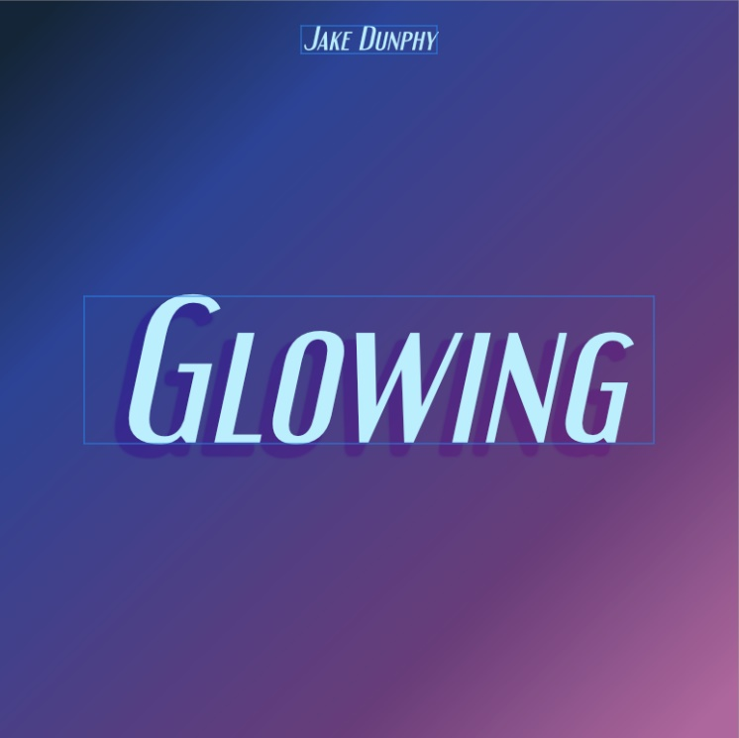
Figure 18 - Proprietary Digital Cover Step 3
Place a Square Star in the centre of the canvas (while holding shift to keep it proportional), and put the shape layer under the text layers but above the background layer. Give the Square Star a solid colour of RGB(222,185,255). Set the opacity of the layer to 50%.
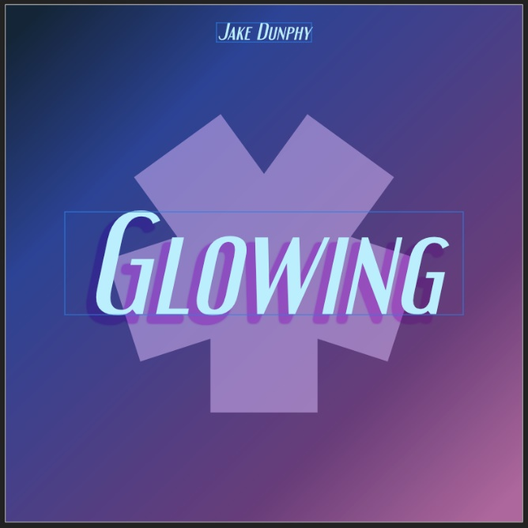
Figure 19 - Proprietary Digital Cover Step 4
Using layer effects, add an Inner glow to the Square Star with the following settings and colour RGB(216,243,255).
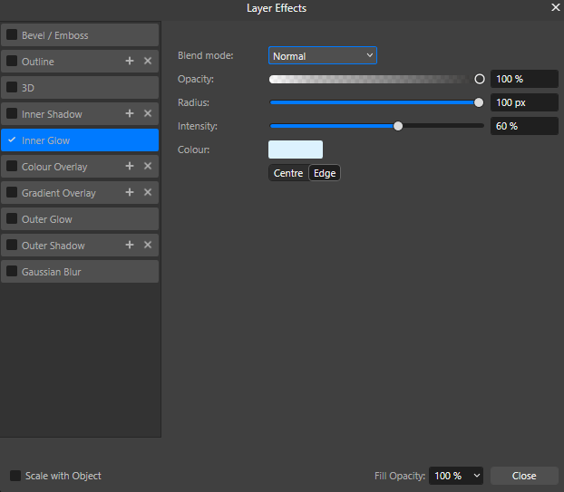
Figure 20 - Proprietary Digital Cover Step 5
Using Segment shapes, fill the four corners of the canvas with rounded corners, then fill the outer edges of the canvas with rectangles. Take care to make sure there are no gaps between the rectangles and the segment shapes.
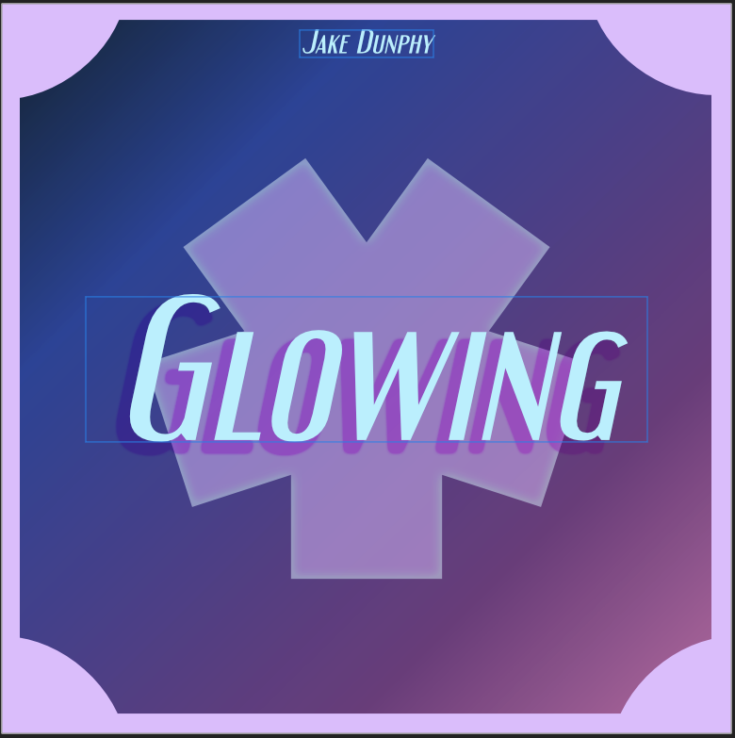
Figure 21 - Proprietary Digital Cover Step 6
Double click on the edge of a rectangle, and the Mesh Warp tool should appear. Use this to make the centre of each rectangle curve inwards.
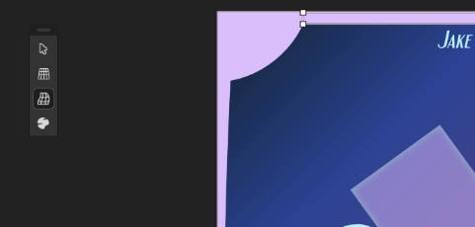
Figure 22 - Proprietary Digital Cover Step 7
Note: The rectangle shapes must be rasterised to use the warp tool, but Affinity may do this for you.
Keep the curves similar but not identical to give the edges some flow.
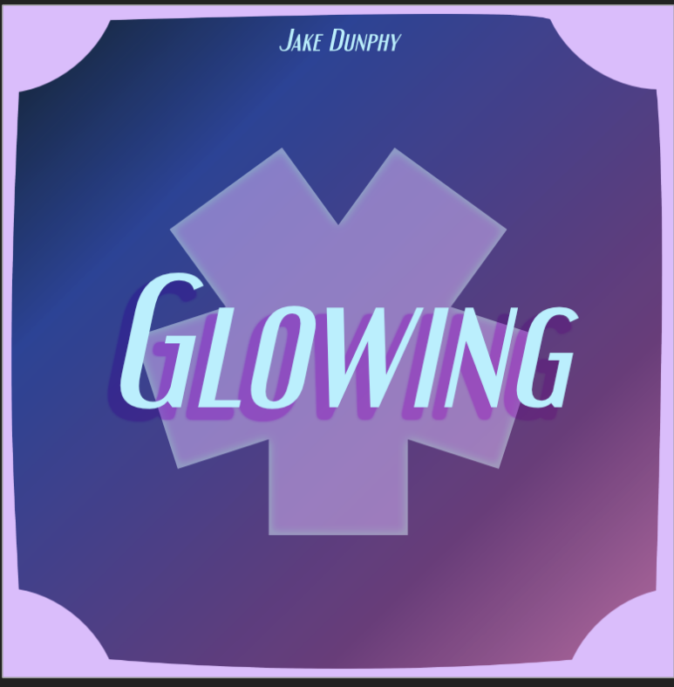
Figure 23 - Proprietary Digital Cover Step 8
The Digital Album Cover is now complete. The remaining assets will be made using this as a base.

Digital Banner (Proprietary):
Duplicate the file for the Digital Album Cover and open it. Change the canvas dimensions to 2480x520px (these are the recommended dimensions for a Soundcloud banner). This can be done by either pressing CTRL+Shift+P, or by going to Document Setup Document Setup.
The Graphic elements will now be misaligned due to the new canvas size. Start by removing all shapes except for the Square Star, and removing the Artist name, but not the “Glowing” text.
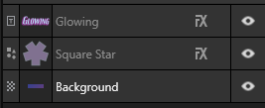
Figure 24 - Proprietary Banner Step 1
As the text layer is not rasterised, change the text size to 96px before adjusting it to the centre of the canvas, then adjust the square star. (Remember to hold Shift while adjusting the size of the Square Star).
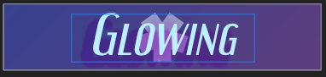
Figure 25 - Proprietary Banner Step 2
The layer effects were made with a larger canvas in mind, so these must be adjusted.
First, change the outer shadow effect on the Glowing text to the following:
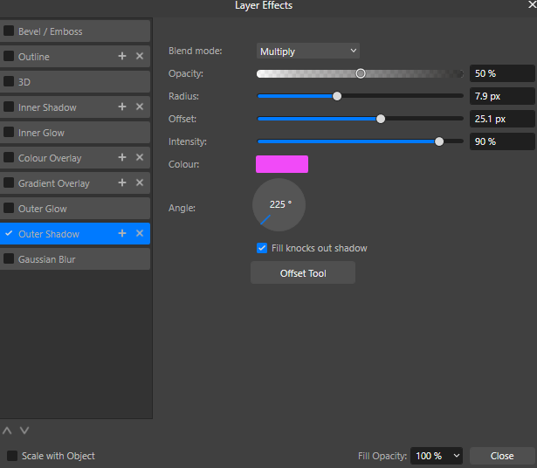
Figure 26 - Proprietary Banner Step 3
Then change the intensity of the inner glow on the Square Star to 35%.
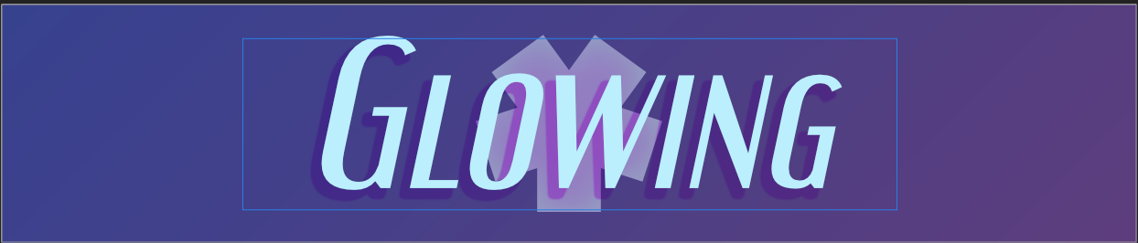
Figure 27 - Proprietary Banner Step 4
This is the finished banner.

Artist Logo (Proprietary - Affinity):
Duplicate the Digital Album Design. Remove the “Glowing” text, and the rectangle shapes on the borders. Take the artist’s name text, change the text size to 200 pts, and place it in the centre of the canvas.
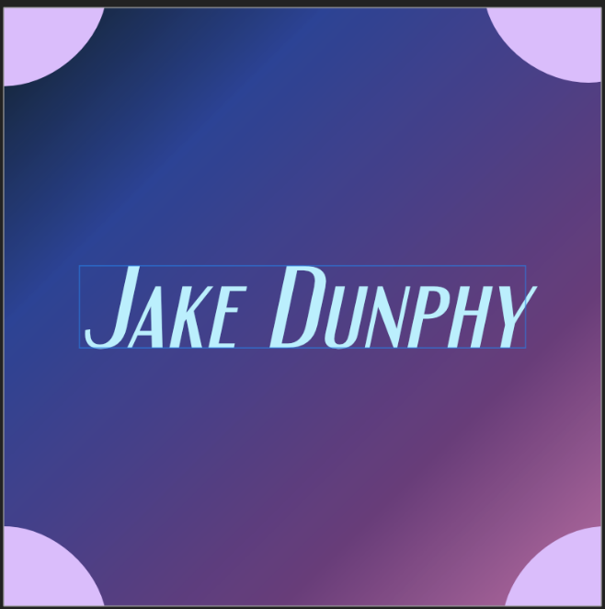
Figure 28 - Proprietary Artist Logo Step 1
Using Layer Effects, add an Outer glow to the text with the following settings and colour RGB(252,193,255).
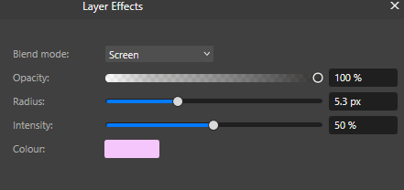
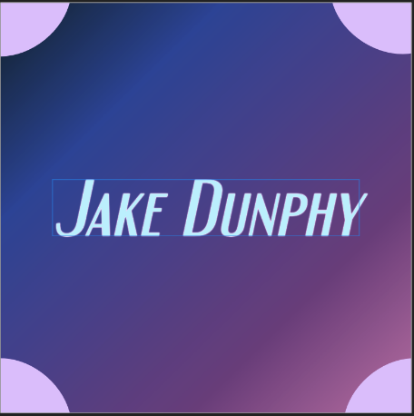
Figure 29 - Proprietary Artist Logo Step 2
This is the finished artist logo.

Track List (Proprietary):
Duplicate the Digital Album Design. This will be used as the base of the Track List Design.
Go to Document Setup and change the canvas size to a vertical A4 page.
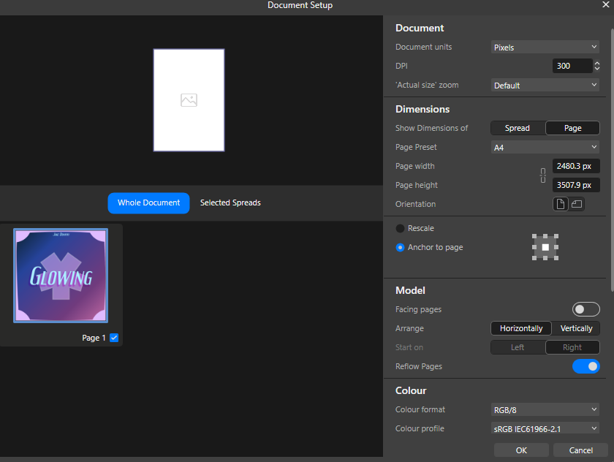
Figure 30 - Proprietary Track List Step 1
Delete all layers except for the “Glowing” text layer, the Square Star, and the Background layer. Hide the Square Star layer by clicking the eye next to the name. Have the Glowing Text box cover the entire page, leaving margins around the edges of the canvas. Change the text size to 48px, and centre align the text.
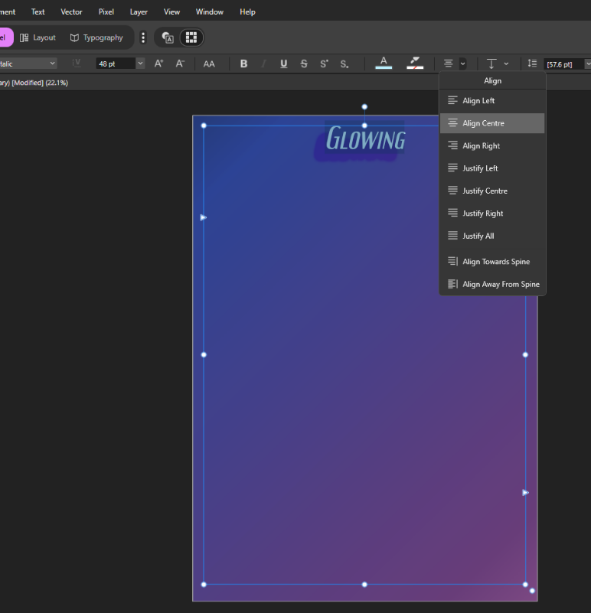
Figure 31 - Proprietary Track List Step 2
Go to layer effects for the text layer, and remove all Layer effects. Type out the names of the tracks on the album, leaving a new line for each track. Change the line spacing to 72px, and change the size of the “Track List” text at the top to 64px.
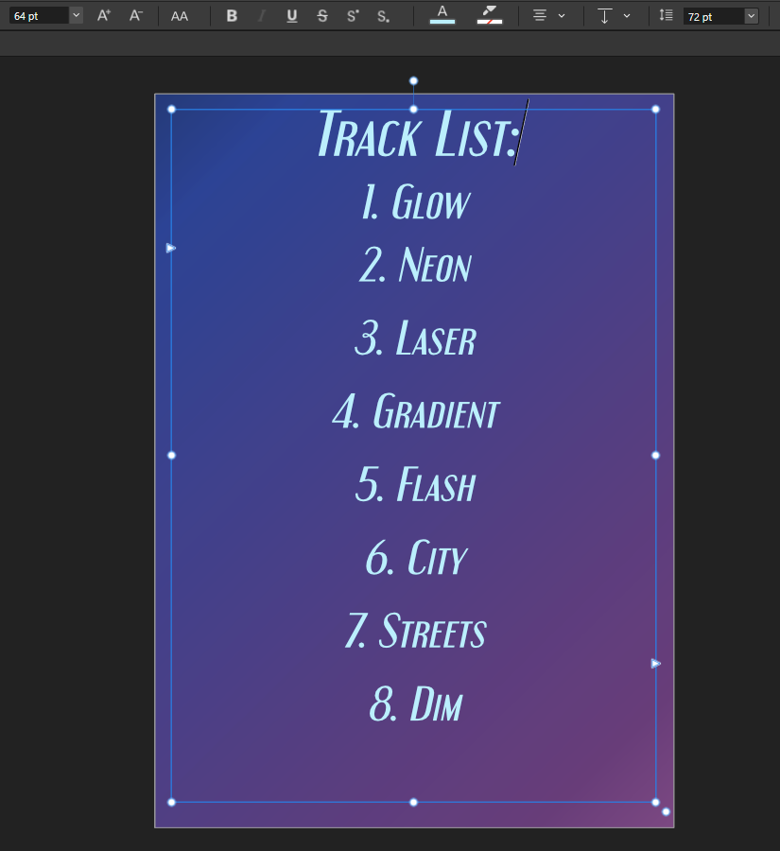
Figure 32 - Proprietary Track List Step 3
Unhide the Square Star, enlarge it so it is bigger than the size of the canvas, place it exactly in the centre of the canvas, and set the opacity to 15%.
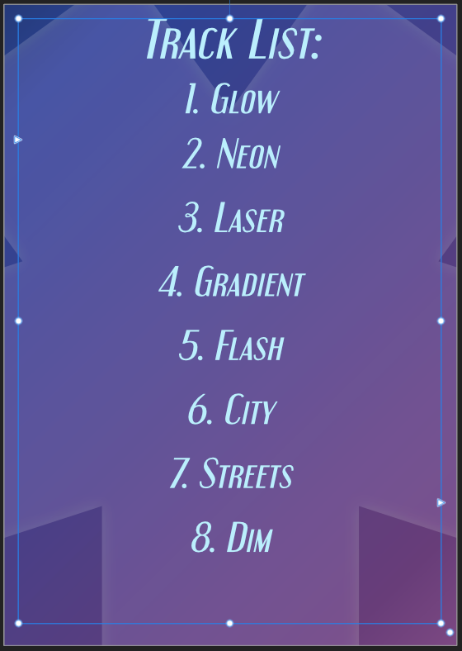
Figure 33 - Proprietary Track List Step 4
This is the finished Track List.

Album Design (Open Source - GIMP):
Create a 5000x5000 image in GIMP.
Select the background layer, then (using the Gradient created during the CD Design section of the Semester 1 Appendix), draw a gradient from the top left corner to the bottom right corner.
Using the text tool, draw a text box in the middle of the canvas. Type the text “Glowing”, then highlight the text. Change the font to “Engebrechtre Regular” (the exact name must be typed), then change the font size to 1300px. Adjust the text box as needed. Set the colour of the text to RGB(94,97,100).
If struggling to align elements correctly, guides can be created by going to Image Guides New Guides (By Percent).
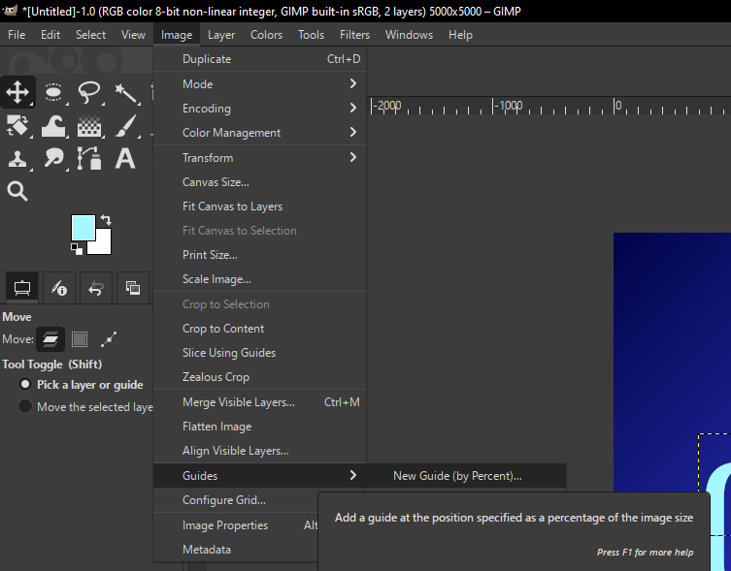
Figure 34 - Open Source Album Logo Step 1
The canvas should look like this
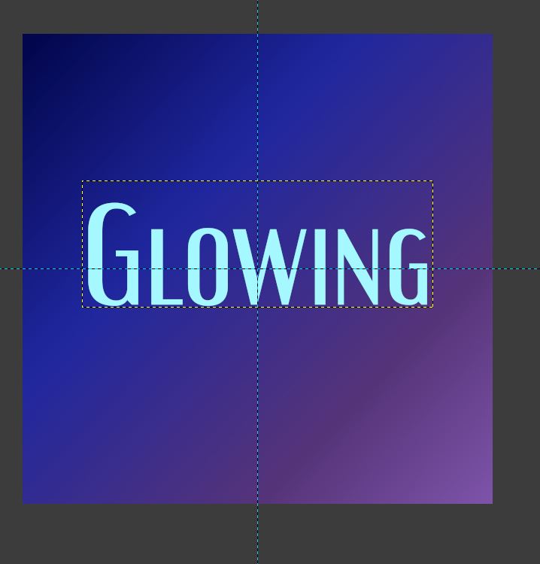
Figure 35 - Open Source Album Logo Step 2
Duplicate the text layer. Move the new layer so it is visible, and change the text size to 1350px (the text box may need to be adjusted). Place the new layer under the original text layer, and place the new text in the same place as the original text. Change the text colour to RGB(88,63,83).
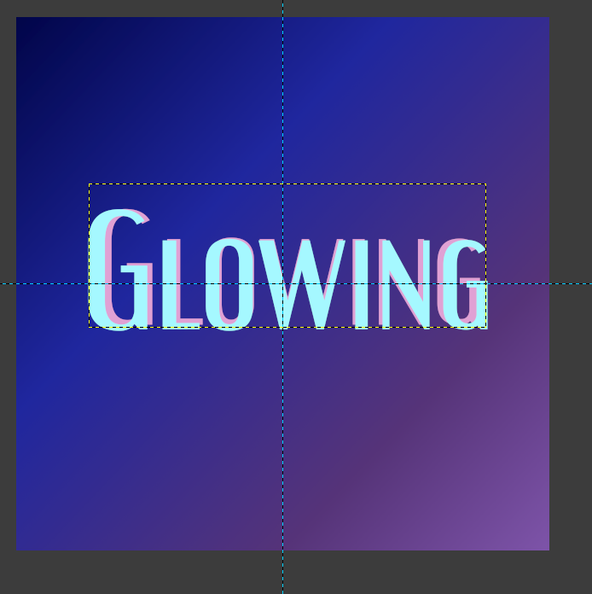
Figure 36 - Open Source Album Logo Step 3
Align the text similarly to the above image. Select the Pink text layer and apply a Gaussian Blur by going to Filters Blur Gaussian Blur.
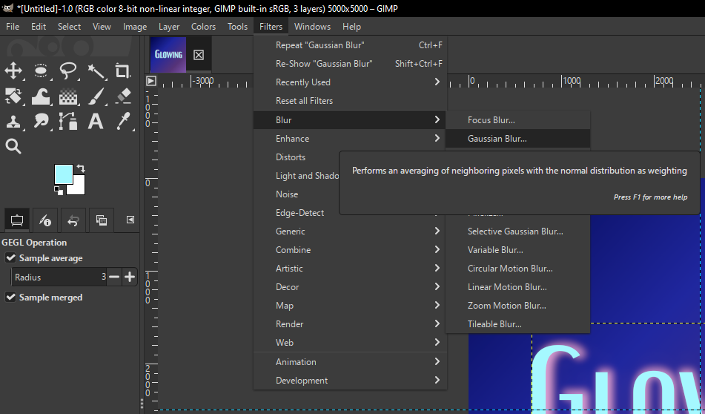
Figure 37 - Open Source Album Logo Step 4
Use the following settings:
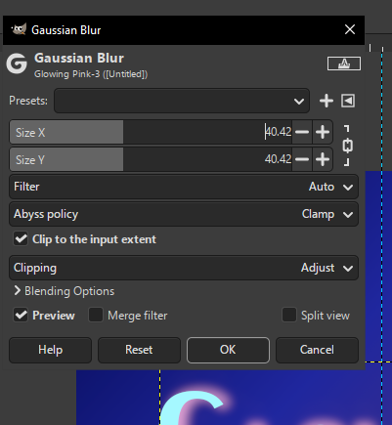
Figure 38 - Open Source Album Logo Step 5
The text should look as follows:
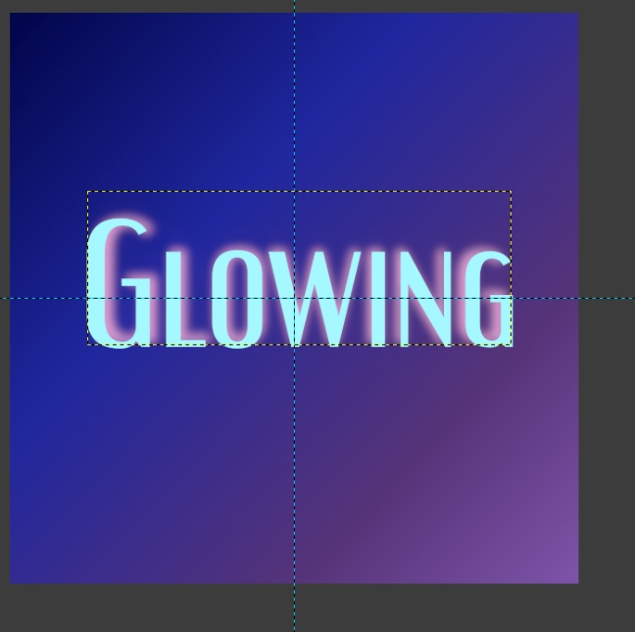
Figure 39 - Open Source Album Logo Step 6
Duplicate the original Blue text layer. Change the text to the name of the artist, and the font size to 200px. Place the new text layer close to the top of the canvas, but leave some room.
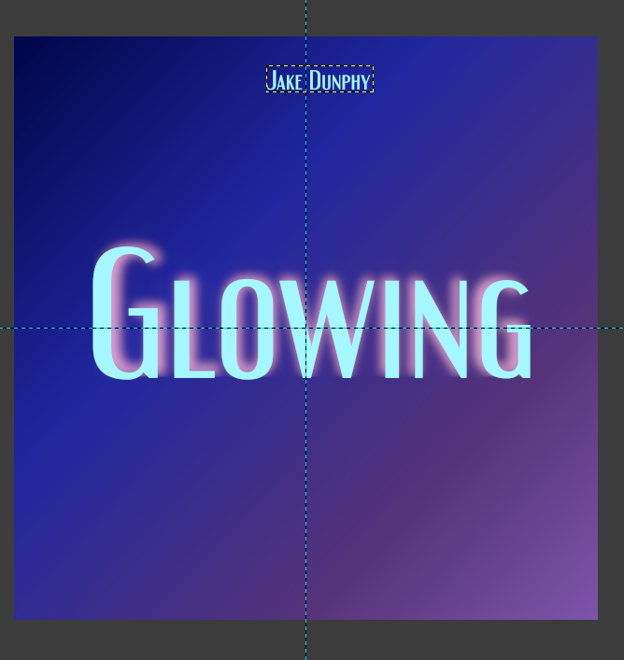
Figure 40 - Open Source Album Logo Step 7
Your canvas should look like the following.
For the CD Design, a Shape graphic was made. Re-use this file for this project, or redo the steps to create a new one in the Semester 1 Appendix. Place the Star shape layer under the text layers but above the background layers. Set the opacity of the layer to 50% Colour the star shape with the pink colour used for the pink text layer previously. Duplicate the star shape and make it slightly larger using the scale tool, place the layer below the original star shape, then colour it the same blue colour used for the main text. Set its opacity to 25%
Apply a Lens Blur to the pink star shape with the following settings (found in the same menu as Gaussian Blur).
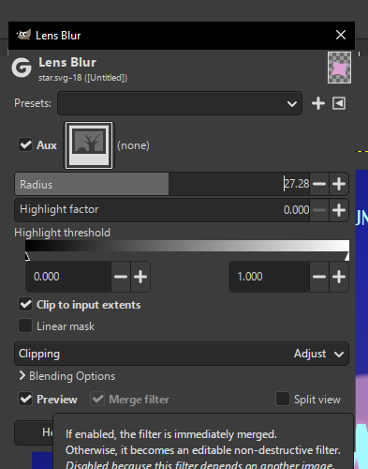
Figure 41 - Open Source Album Logo Step 8
The canvas should have something similar to the following.
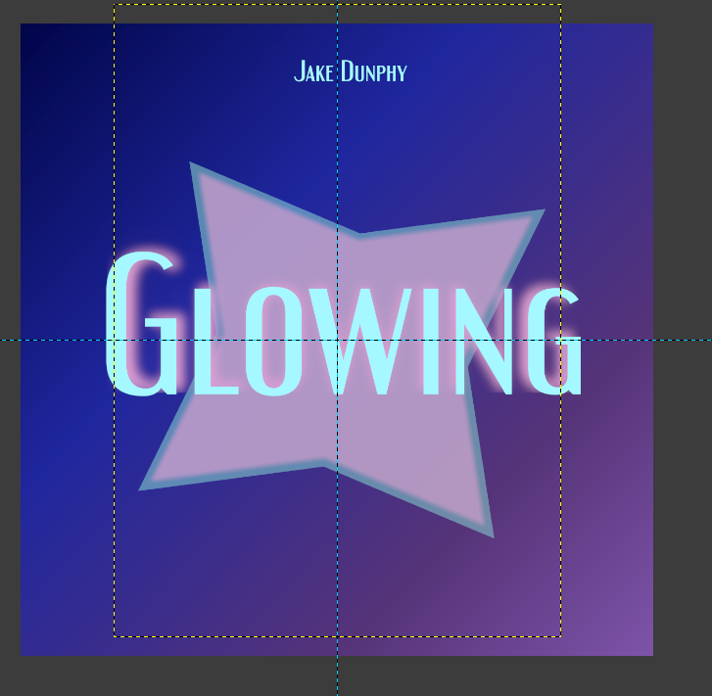
Figure 42 - Open Source Album Logo Step 9
Create a new layer above the background layer. Using the ellipse select and fill tool, colour the corners of the canvas with circles. Fill in the gaps between the circles along the edges of the canvas with the same colour, using the rectangular select tool and fill tool.
The canvas should look as follows.
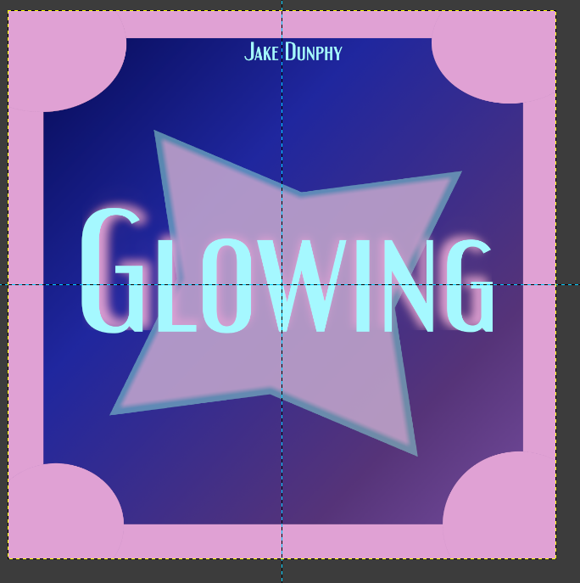
Figure 43 - Open Source Album Logo Step 10
Cut curved holes into the rectangular edges by partially selecting them with the ellipse select tool, then using the CTRL+X shortcut to Cut.
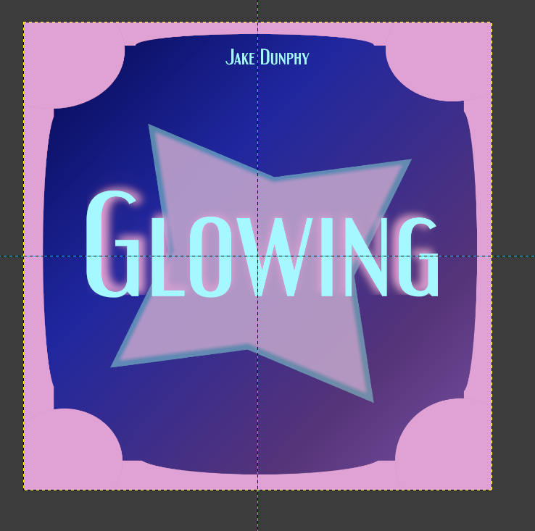
Figure 44 - Open Source Album Logo Step 11
The album design is now completed.

Digital Banner Design (Open Source – GIMP):
Duplicate the project file for the Digital Album Design. Delete the shapes around the border of the canvas and the artist’s name. Merge the two star shapes into one layer, and merge the two text boxes into one layer. Change the image size to 2480x520px by going to Image Canvas Size.
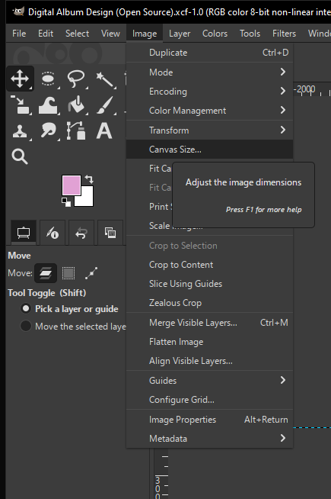
Figure 45 - Open Source Banner Step 1
Select the text, star shape, and background together by holding Shift and clicking each layer, then use the scale tool to make them a correct size for the new canvas. Adjust the background so the gradient can be seen more clearly, then adjust the star shape and text again to place it in the centre of the new canvas.

Figure 46 - Open Source Banner Step 2
The banner design is now complete.

Artist Logo Design (Open Source – GIMP):
Duplicate the Digital Album Design. Delete the layer for the border of the canvas. Make new circles in the corners of the canvas, but don’t fill in the gaps with the rectangle select this time. Delete the star shape, and the pink text, and replace the blue text with the artist name. The text size and position will likely need to be adjusted.
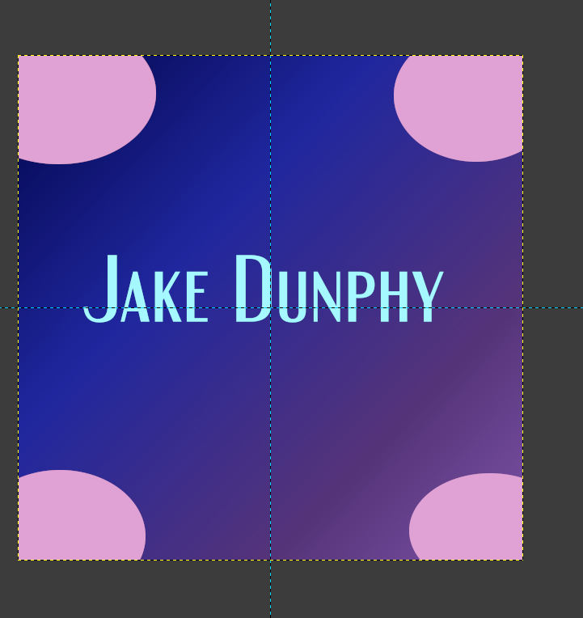
Figure 47 - Open Source Artist Logo Step 1
The Artist Logo Design is now finished.

Track List Design (Open Source - GIMP):
Duplicate the Digital Album Design once more. Delete everything except for the Base blue text, the star shape, and the background. Change the Canvas size to 2481x3508px.
Centre the star shape and change the opacity of the layer to 10%. Adjust the text box so it covers the entire canvas, leaving room around the edges. Type “Track List” and change the font size to 400px and the font to Engebrechtre Italic. Use the toolbar on the left side to centre align the text. Add a new line, change the font size to 200px, and add the names of the tracks. Keep the text in the centre. Change the spacing between the lines to 75px using the side bar.
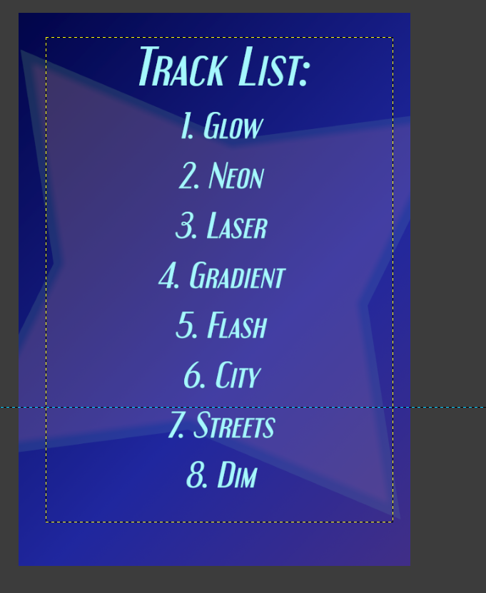
Figure 48 - Open Source Track List Step 1
The track list is now complete.

‌ Poster Design (Proprietary - Affinity):
Duplicate the Track List Design. Change the canvas size to 18x24in. Change the colour format to CMYK. Replace the background with a solid colour rectangle of colour CMYK(60,88,16,3).
Following the mock-up, place the Track List on the right side of the canvas. Change the text of the Track List header to 144pt, and the names of the tracks to 96pt. Change the line spacing to 144pt.
Resize the Star Square and put it where the Logo space is in the mockup.
Open the Digital Album Design file. Copy the Glowing text and the artist name and paste it into the Poster file. Rasterize the Glowing text (preserve the Layer FX) so it can be resized to fit in the middle of the Star Square. Keep the Artist Name the same size, and slot it just above the Glowing text.
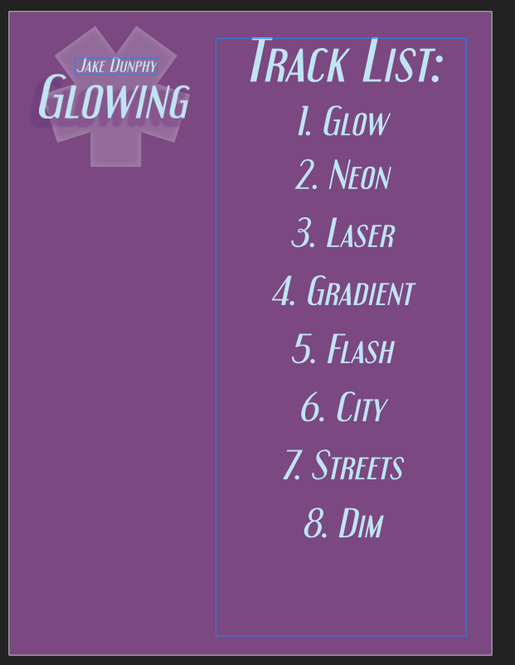
Figure 49 - Proprietary Poster Step 1
This is the progress so far.
Place a new block of text in Engebrechtre Bold where the Extra Details box is in the mock-up. Add text pertaining to the Release date of the album, how it will be released, and what platforms it will be released on. Experiment with text size and line spacing to make it look less static. Left align the text.
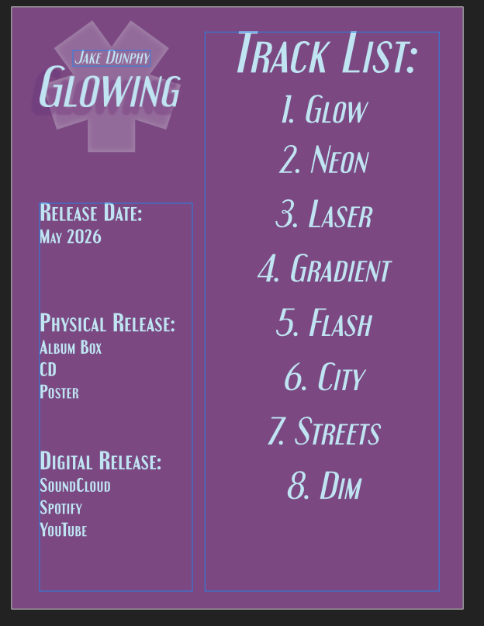
Figure 50 - Proprietary Poster Step 2
The poster is now finished.

Poster Design (Open Source - GIMP):
Duplicate the Track List Design. Open it and change the canvas size to 18x24in. Delete the background and replace it with the rectangular select and a fill of RGB(49,25,52).
Following the mock-up, place the Track List on the right side of the canvas. Change the text of the Track List header to 144pt, and the names of the tracks to 96pt. Change the line spacing to 144pt.
Using the Resize and Move tools, put the Square Star in the top left corner where the Logo space is in the Mockup. Change its opacity to 50%.
Open the Digital Album Design file. Copy the Glowing text and the artist name and paste it into the Poster file. Rasterize the Glowing text by going to Layer Discard Text Information so it can be resized to fit in the middle of the Star Square. Keep the Artist Name the same size, and slot it just above the Glowing text.
Place a new block of text in Engebrechtre Bold where the Extra Details box is in the mockup. Add text pertaining to the Release date of the album, how it will be released, and what platforms it will be released on. Experiment with text size and line spacing to make it look less static. Left align the text.
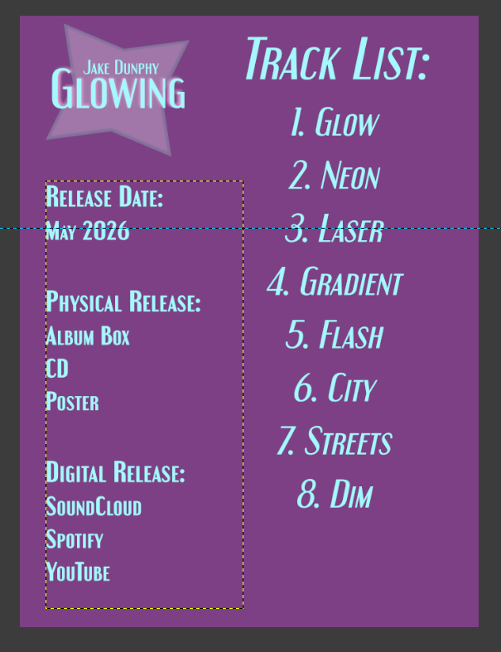
Figure 51 - Open Source Poster Step 1
The Poster is now finished.

Basic Album Box Model (Proprietary - MAYA):
Make a new project in Maya.
In the Poly Modelling tab, create a cube.
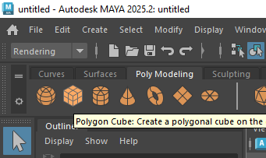
Figure 52 - Proprietary Box Model Step 1
Hold the right mouse button down over the Cube, and select Face select mode. 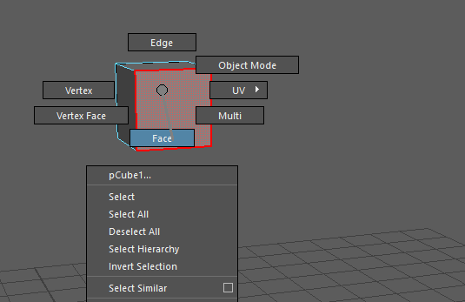
Figure 53 - Proprietary Box Model Step 2
Select the Move tool.
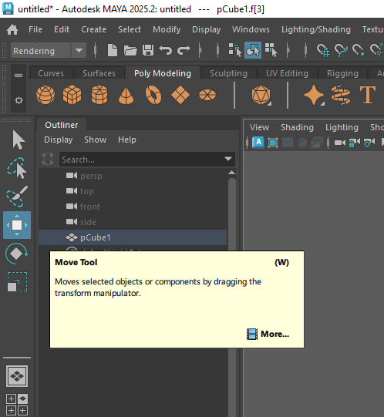
Figure 54 - Proprietary Box Model Step 3
Stretch the top of the box outwards, then do the same for the side. This should make a rectangular shape that is longer than it is wide.
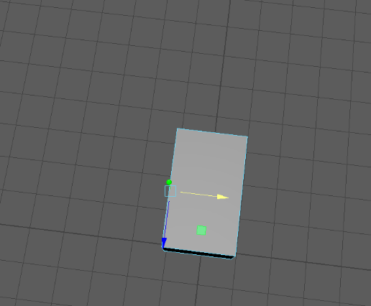
Figure 55 - Proprietary Box Model Step 4
Go to the bottom of the Cube, and push the bottom side inwards so that the cube is nearly completely flat.
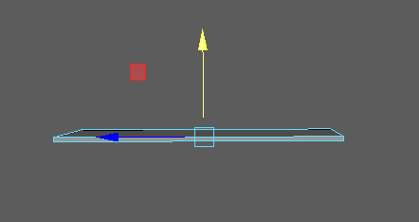
Figure 56 - Proprietary Box Model Step 5
Duplicate the cube (switch to Object select mode to do so, then push CTRL+C and CTRL+V). Use the rotate tool to turn it sideways.
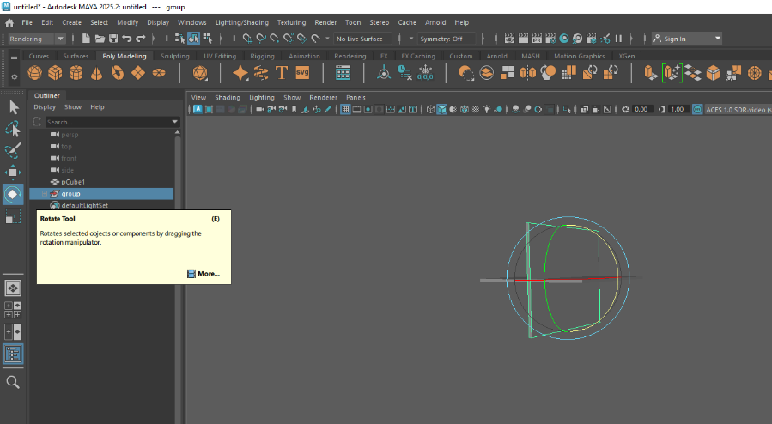
Figure 57 - Proprietary Box Model Step 6
Move the new side so that it is touching the original cube.
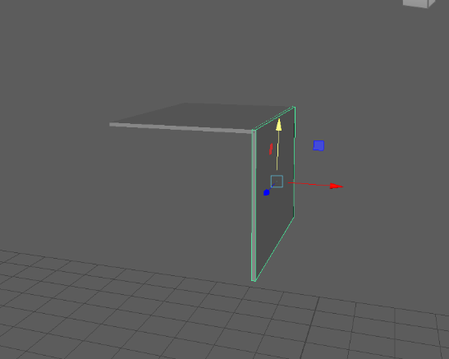
Figure 58 - Proprietary Box Model Step 7
Using the scale tool, make the side shorter. (You will likely need to readjust its position).
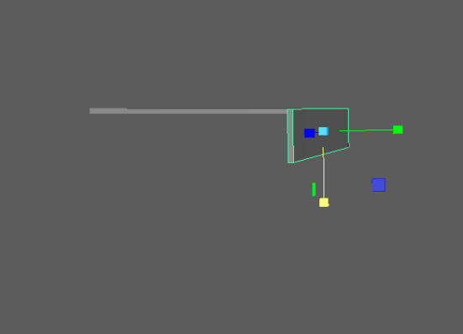
Figure 59 - Proprietary Box Model Step 8
Duplicate this side and put it on the other side of the original cube.
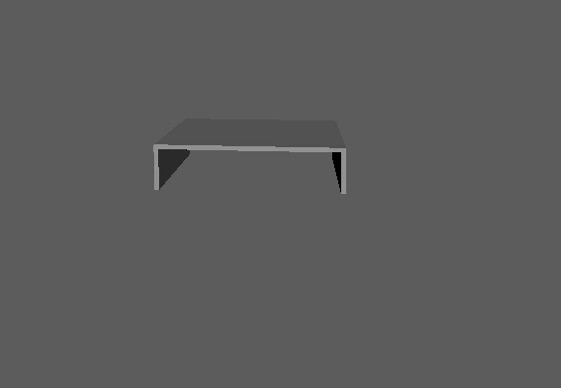
Figure 60 - Proprietary Box Model Step 9
Duplicate one of the sides, and do the same with the top and bottom. Resize the cubes as needed.
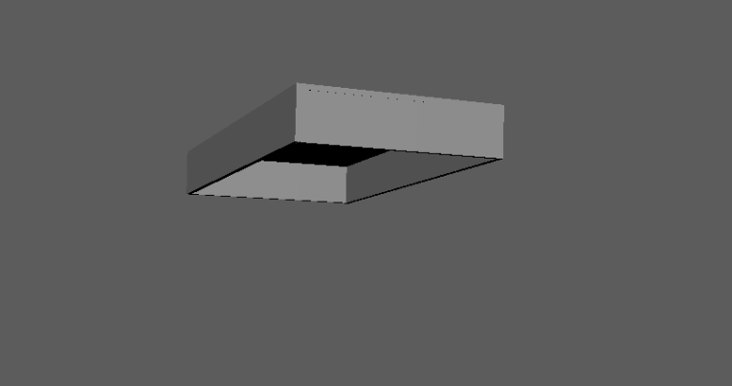
Figure 61 - Proprietary Box Model Step 10
This is the top lid of the box.
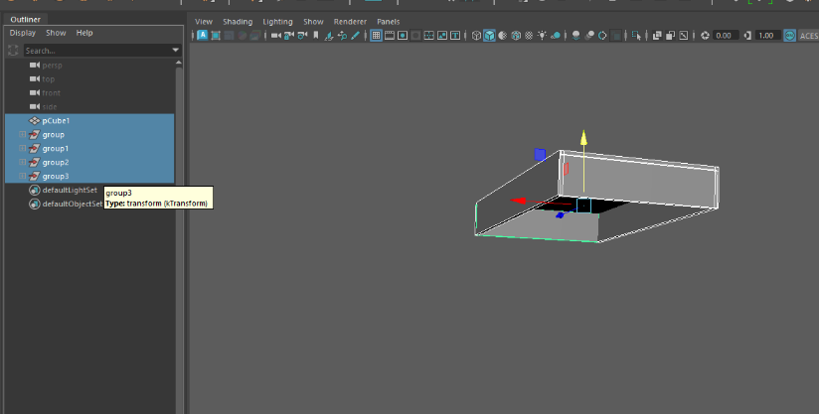
Figure 62 - Proprietary Box Model Step 11
Select all of the shapes in the side panel.
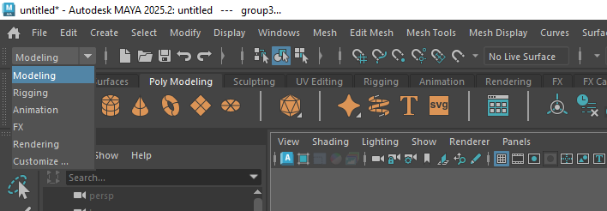
Figure 63 - Proprietary Box Model Step 12
Change to Modelling mode in the top panel, then select Mesh Combine. This will turn the top lid into one shape. Duplicate the top lid, and rotate it. Make it slightly smaller so the top lid can go over it.
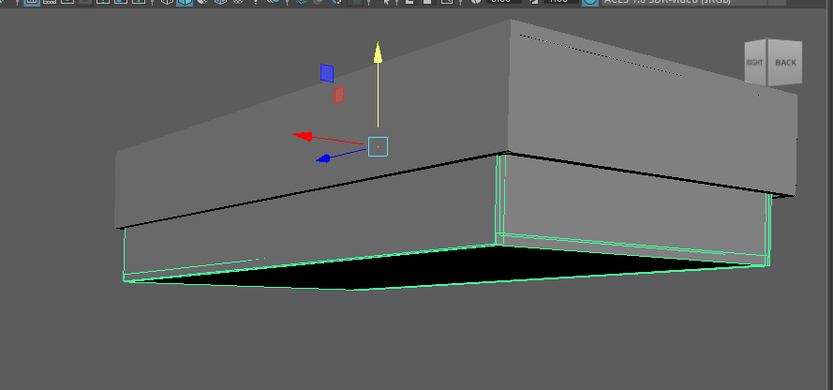
Figure 64 - Proprietary Box Model Step 13
The box is now finished.

Basic Poster Model (Proprietary – MAYA):
Using the same project file as for the Box Model, crate a Polygon Plane in Maya.
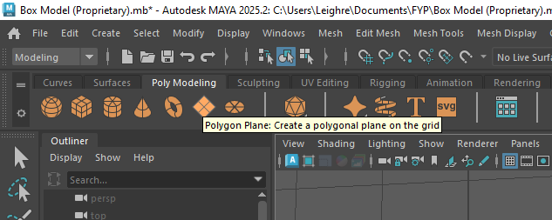
Figure 65 - Proprietary Poster Model Step 1
Using the scale tool, make the poster longer than it is wide.
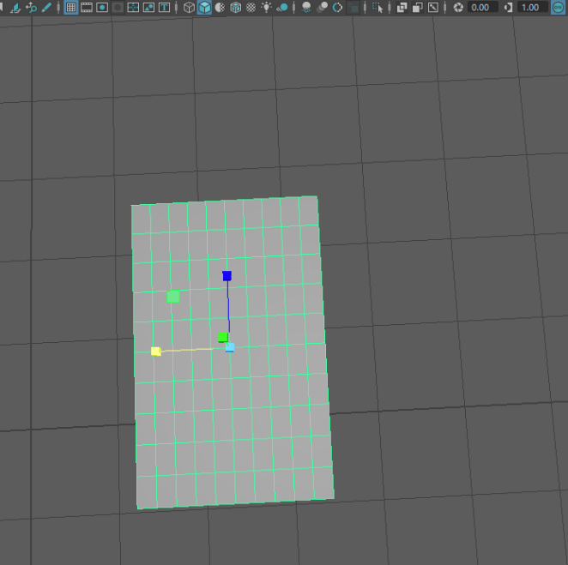
Figure 66 - Proprietary Poster Model Step 2
Hold down the right mouse button on the poster, and select Face Select and select the top half of the poster.
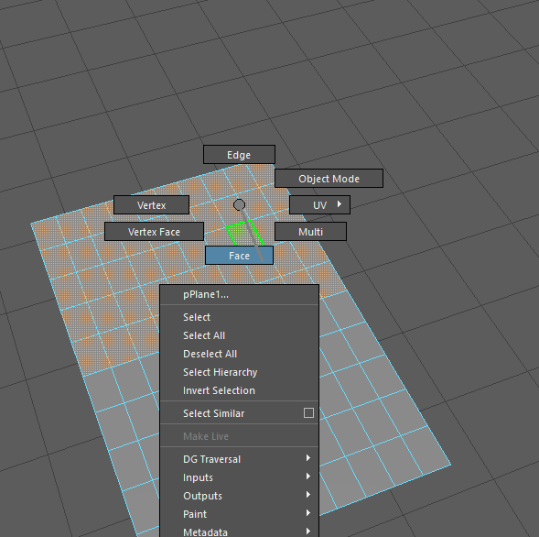
Figure 67 - Proprietary Poster Model Step 3
Change to the rotate tool, and press D to move the pivot. Place the pivot in the centre of the poster.
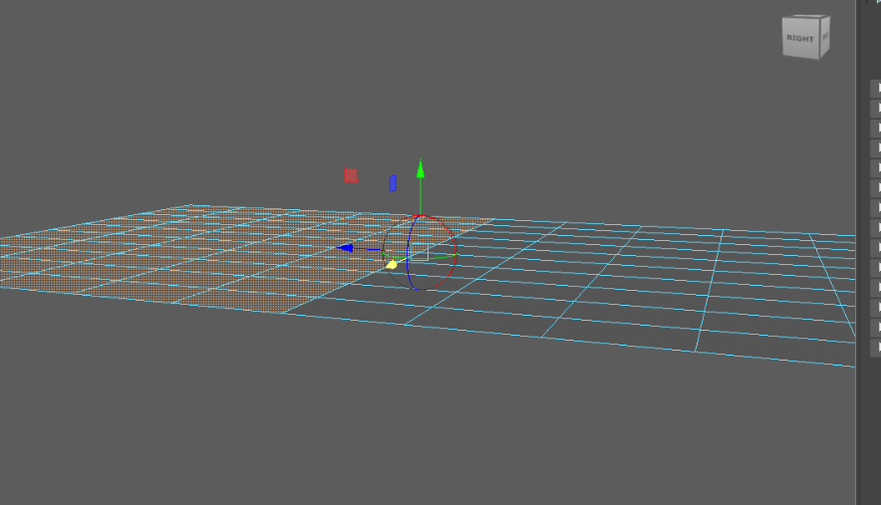
Figure 68 - Proprietary Poster Model Step 4
Press D again to return to rotate mode. The poster can now be folded.
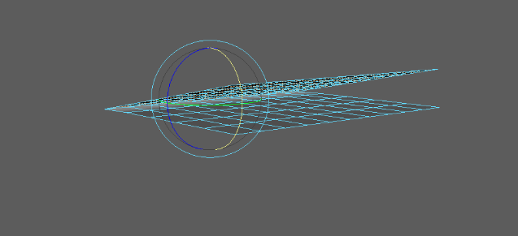
Figure 69 - Proprietary Poster Model Step 5
The basic model is now finished.

‌Basic Box Model (Open Source – Blender):
Create a new project in Blender. Create a Cube (the program might’ve created one for you when you made the project). Using the scale tool, flatten it down and make it longer.
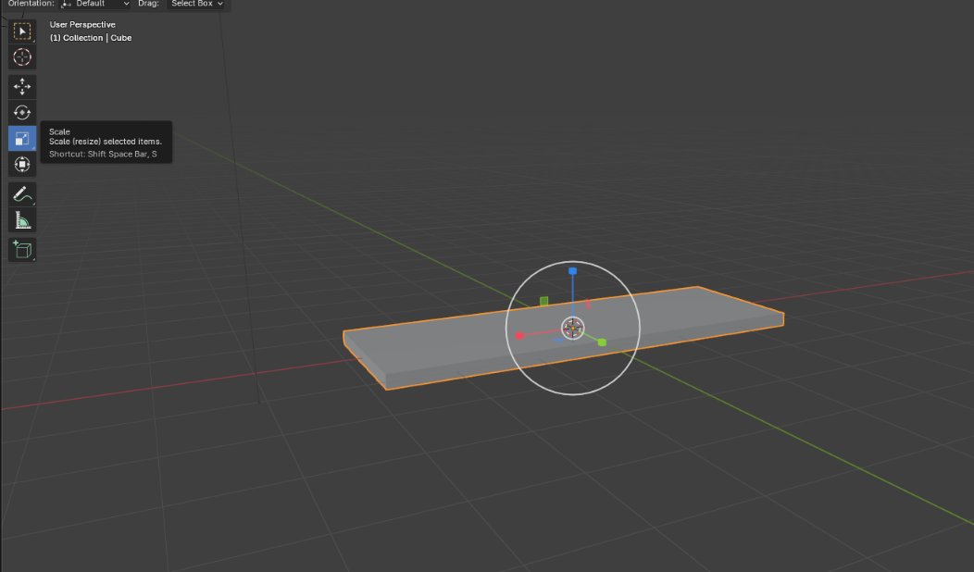
Figure 70 - Open Source Box Model Step 1

To create the sides of the cube, click the “Add Cube” button. Place the mouse in the top left corner of one side of the cube (the cursor should be against the side of the cube rather than facing downwards). Click and drag the mouse to the top right corner, then drag it downwards slightly to make the side of the Cube. Let go of the mouse, and the tool will now be going outwards to decide the width. Keep the width roughly the same as the original cube. Do this for all four sides of the box.
The box will likely not look completely accurate.
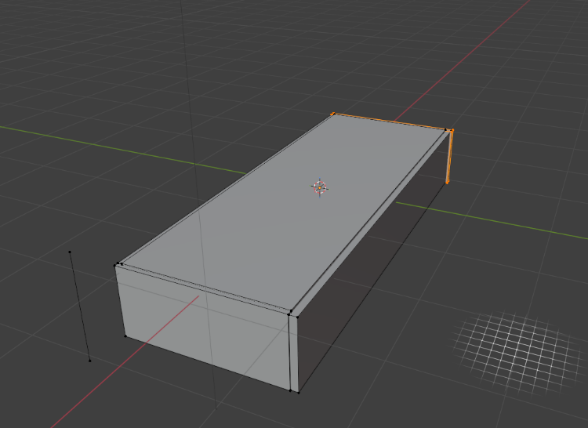
Figure 71 - Open-Source Box Model Step 2
Use the Move and Scale tools together to readjust it.
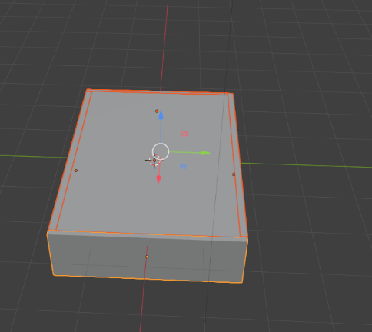
Figure 72 - Open-Source Box Model Step 2
Select all of the individual cubes that have been created, and push CTRL+J to join them together.
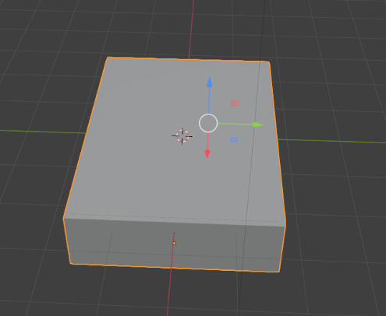
Figure 73 - Open-Source Box Model Step 3
The top half of the box has been created.
To create the bottom half, copy and paste the top half, rotate it upside down, and make it slightly smaller so the top half can slot over it.
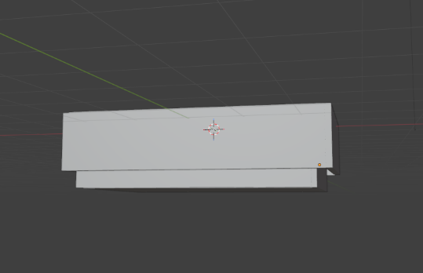
Figure 74 - Open-Source Box Model Step 4
The box model is now finished.

‌

Poster Model (Open Source – MAYA):
In the same project file that the Box Model was created in, create a plane that is longer than it is wide. This is made by going to the “Add” menu in the top ribbon, then going to Mesh Plane.
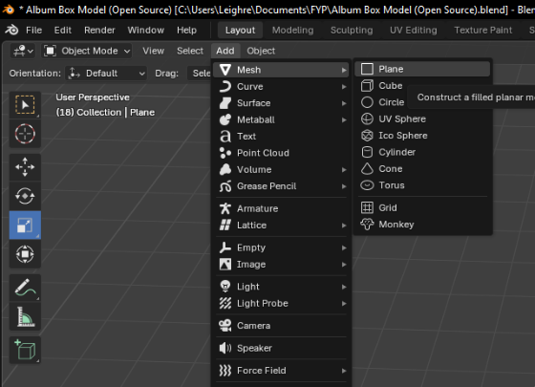
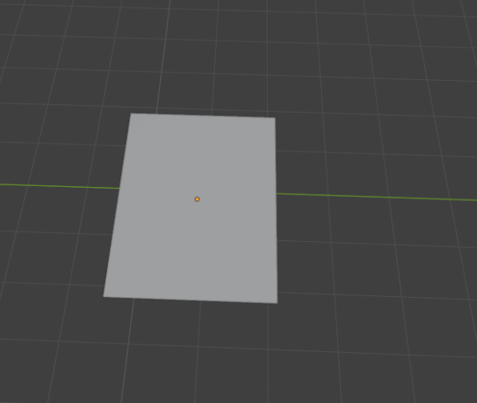
Change to Modeling mode by clicking the button in the top ribbon. Select the Knife tool and make a cut horizontally across the centre of the poster. Push Enter to complete the cut.
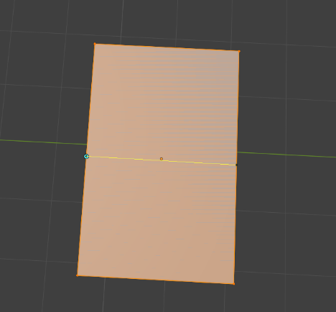
Click on the new centre line, and then click the “Edge” button at the top of the screen. This will open a box, where you click the plus icon. This creates a new orientation.
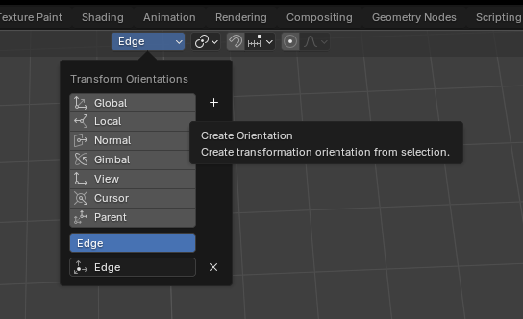
Right next to the “Edge” button, click on the two circles icon and select “Active Element”.
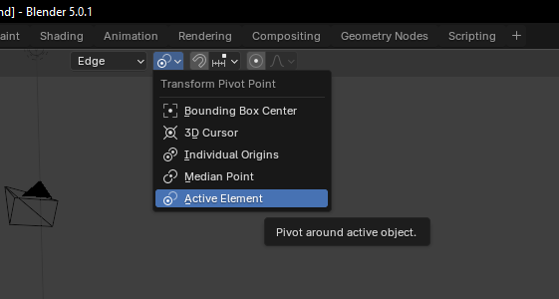
At the bottom left of the screen, open the “Create Orientation” menu, and make sure that the “Overwrite Previous” tick box is enabled.
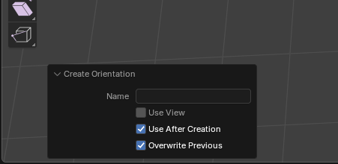
Using the multiselect tool, select the top 3 edges and the middle edge of the poster, and use the rotate tool to check that the poster can fold. (Hold down SHIFT to select multiple edges).
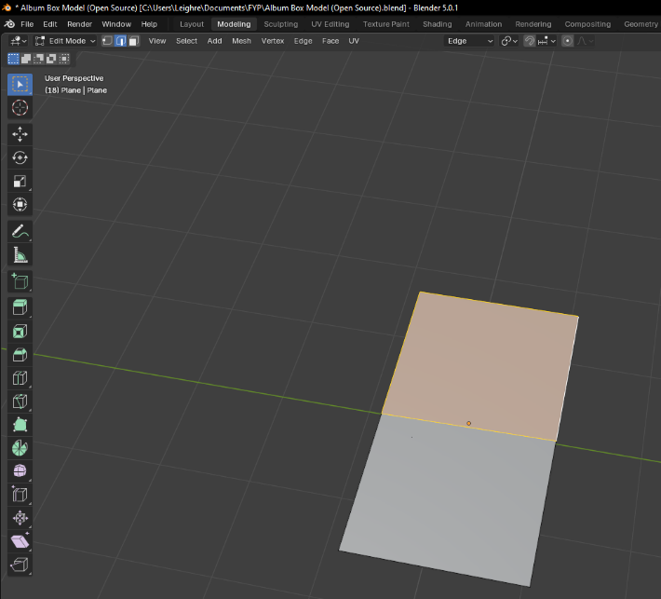
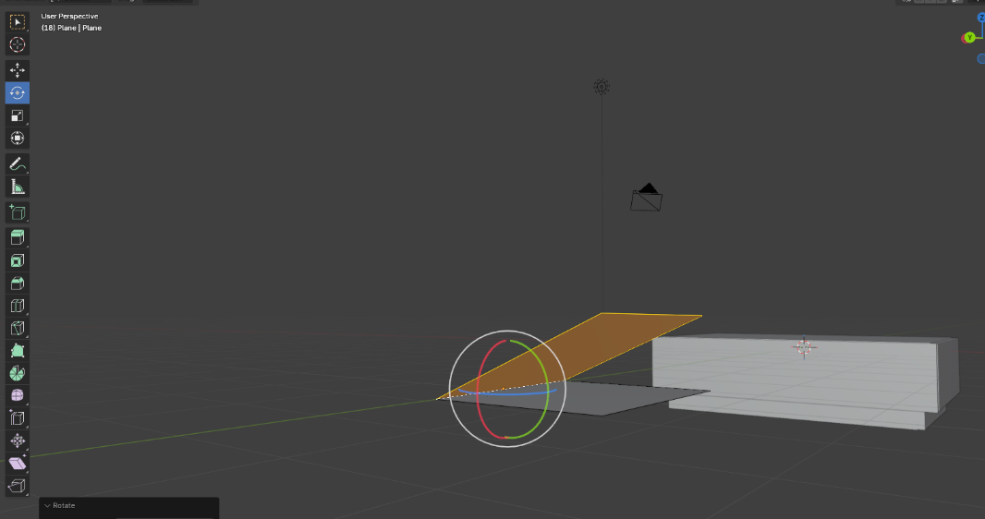
The poster model is now complete.

Album Box Texture (Top – Proprietary):
Make a new file that is taller than it is wide. Create a Rectangle with four Rectangles attached to the edges. This should match the shape of the 3D box previously made in Maya.
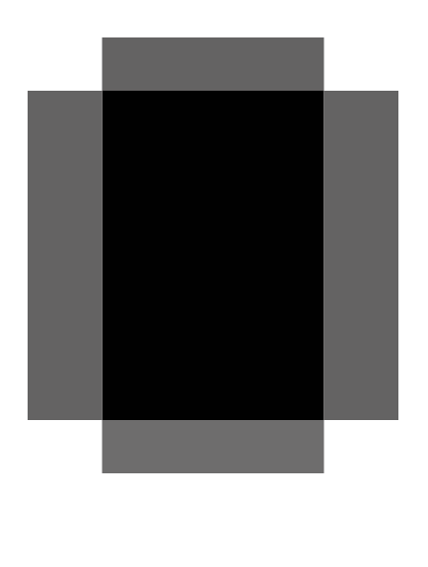
Figure 75 - Proprietary Box Top Step 1
Change the colour of all five shapes to #7E4185, which should match the poster design made previously.

Figure 76 - Proprietary Box Top Step 2
Open the Digital Album Cover made previously, and copy and paste all assets (except for the background and outer edges) into the new project. Rasterise them and arrange them as follows.
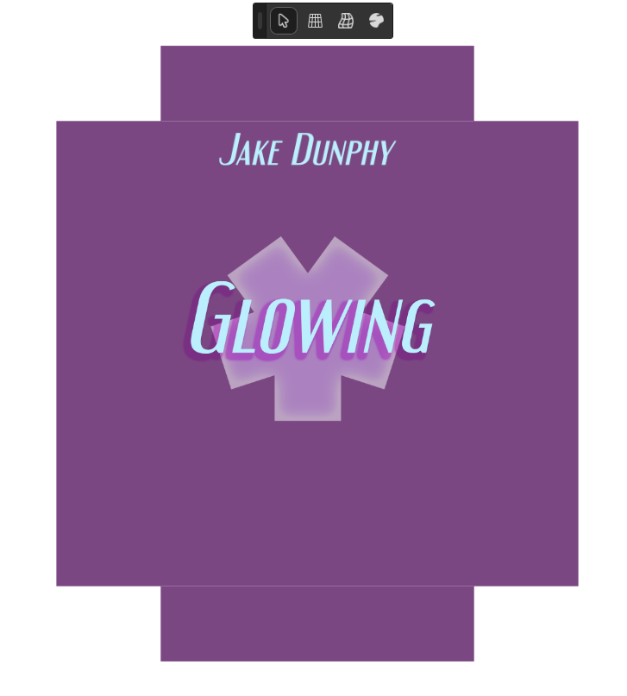
Figure 77 - Proprietary Box Top Step 3
Adjust the layer FX of the Glowing text to the following.
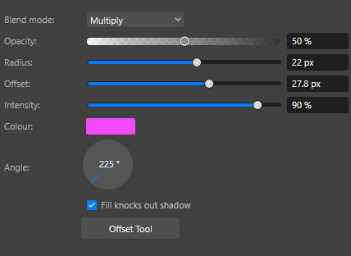
Figure 78 - Proprietary Box Top Step 4
Copy the Glowing text, turn it sideways, make it smaller, and place it onto the left flap of the box.

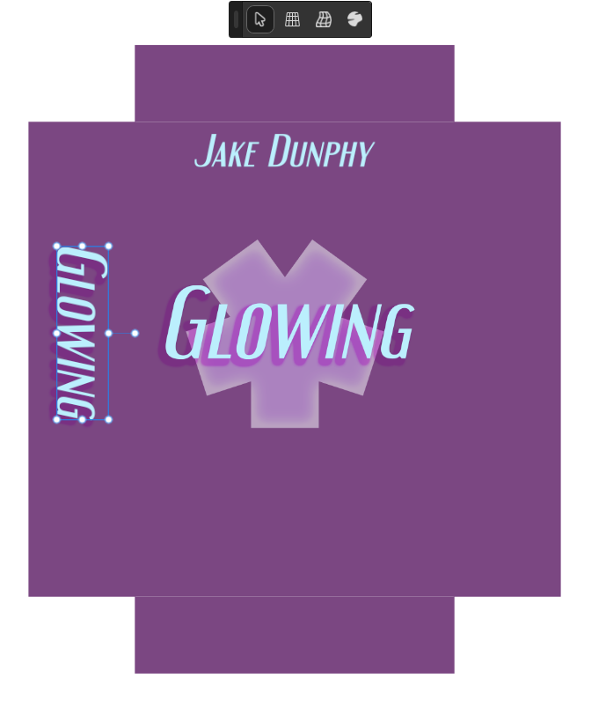
Figure 79 - Proprietary Box Top Step 5
The box top is now finished. Make sure to export the file as a transparent PNG.

Album Box Texture (Bottom – Proprietary):
Duplicate the file for the Top texture, and remove everything except for the base from it. Open the file for the Track List design and copy all of its assets (except for the background). Arrange them as follows.
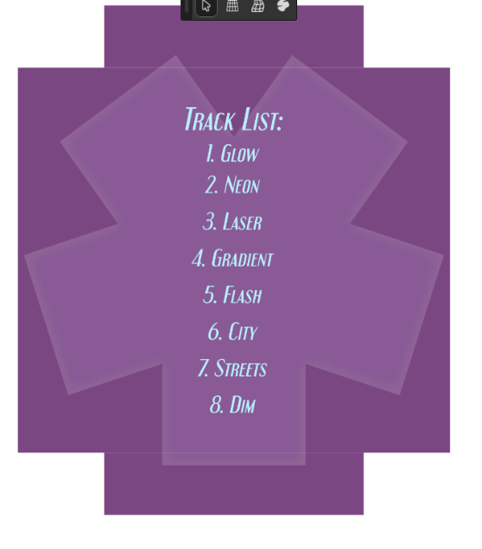
Figure 80 - Proprietary Box Bottom Step 1
The album box bottom is now finished. Again, remember to export as a transparent PNG.

Album Box Texture (Top – Open Source):
Create a new file in GIMP that is taller than it is wide. Make a new layer, and fill in a rectangle selection with colour #7E4185. This will be the top of the box. In another new layer, create another rectangle that will serve as the top flap of the box. Copy and paste this shape and move it to the bottom to make the bottom flap of the box. Do the same steps for making the side flaps. The result should be the following.

Figure 81 – Open Source Box Top Step 1
Open the file for the Digital Album Design made previously. Copy the text and the shape and place it into the new project. Arrange them as follows.
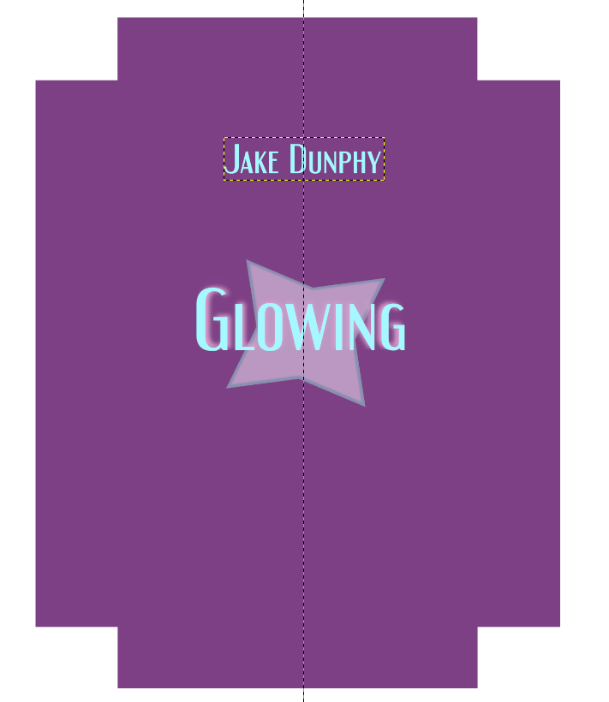
Figure 82 - Open Source Box Top Step 2
Duplicate the Glowing Text, make it smaller, rotate it sideways, and place it onto the left flap of the box.
‌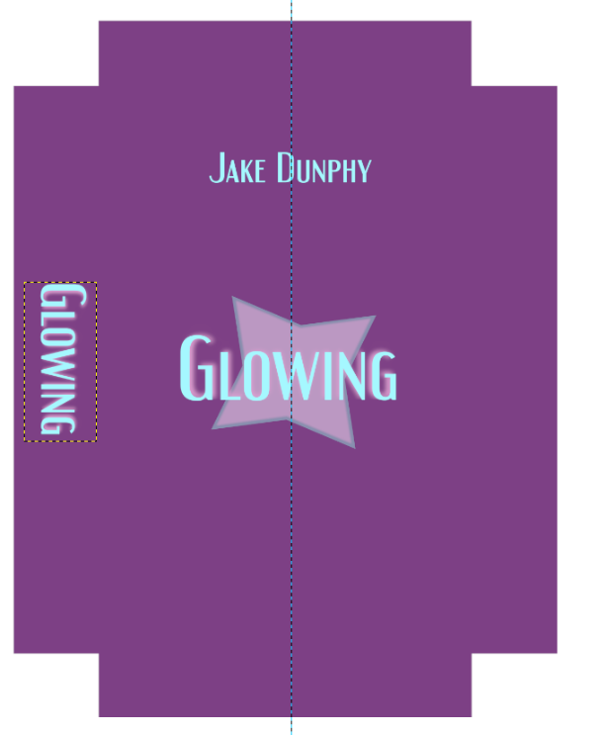
Figure 83 - Open Source Box Top Step 3
The Box Top is now finished. To export it as a transparent PNG, delete the background layer.

Album Box Texture (Bottom – Open Source):
Duplicate the file for the box texture just made, and remove everything except the base. Open the file for the Track List design made previously, and copy paste everything (except the background) into the new project. Arrange as follows.
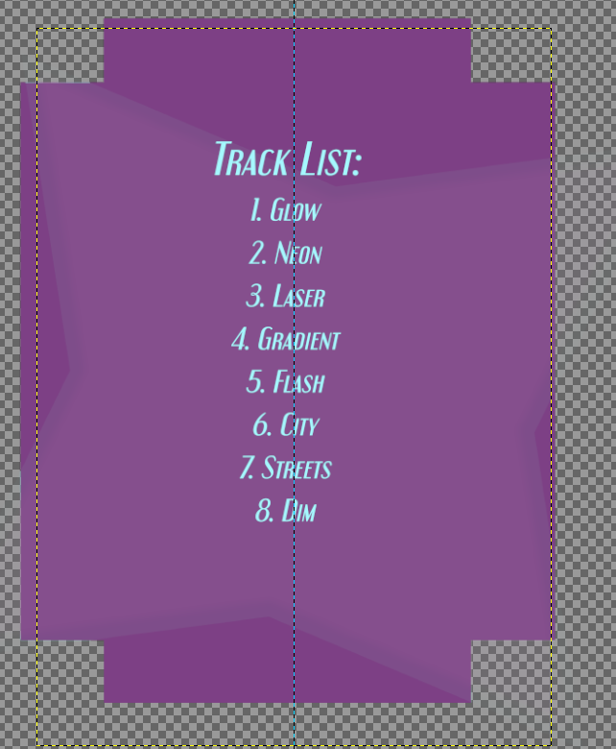
Figure 84 - Open Source Box Bottom Step 1
The Box Bottom is now finished.

T-Shirt Design (Proprietary):
Find a T-Shirt Template online, preferably one with clear copyright.
Using the Flood Select Tool, select the entirety of the front and back sides of the T-Shirt. Then go to Pixel in the ribbon and copy and paste the selection into a new layer. Delete the background layer.
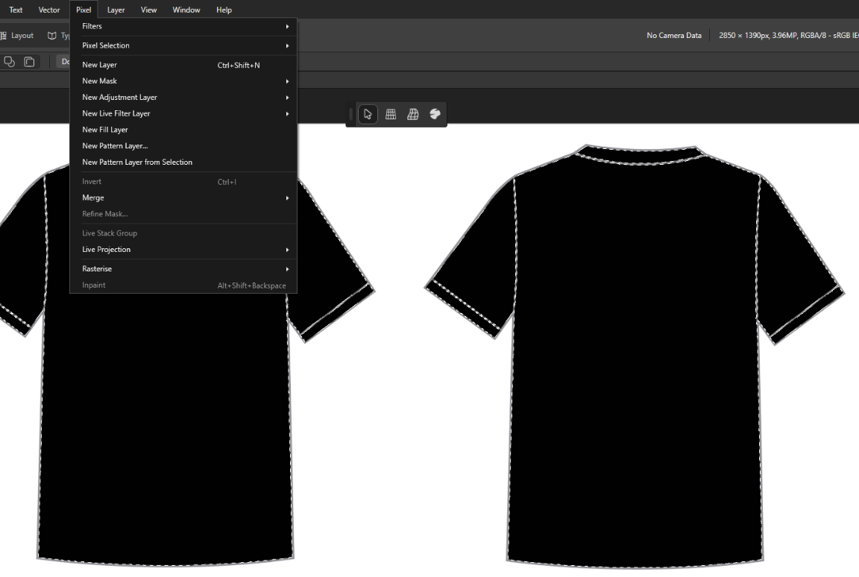
Figure 85 - Proprietary T-Shirt Design Step 1
Keep the selection, and use the Flood Fill Tool to change the colour of the t-shirt to Hex #9D4990.
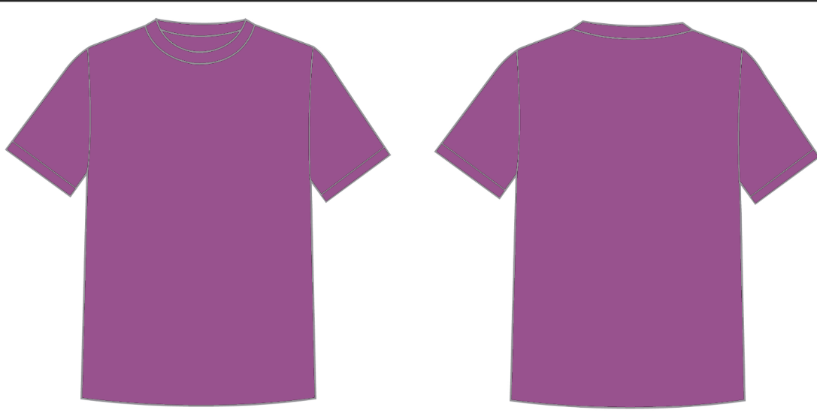
Figure 86 - Proprietary T-Shirt Design Step 2

Open the Digital Album Design file and copy and paste the logo and Star Square into the T-Shirt project. Rasterize both layers (set “Preserve Layer FX” to off) and place them onto the front of the t-shirt.
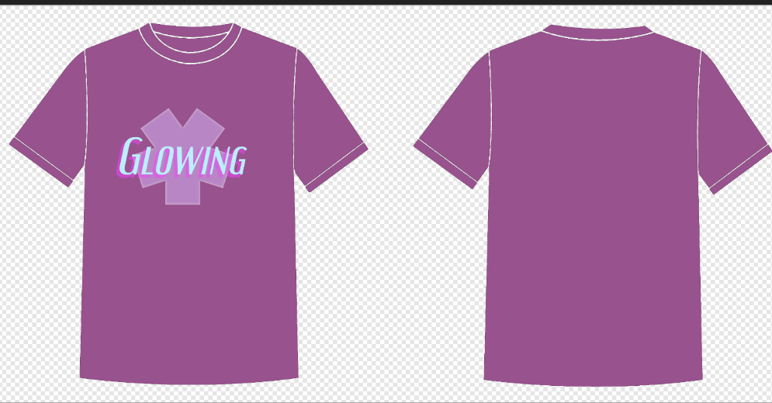
Figure 87 - Proprietary T-Shirt Design Step 3
Open the Track List Design file, and copy and paste the track list text over. Place it onto the back of the t-shirt.
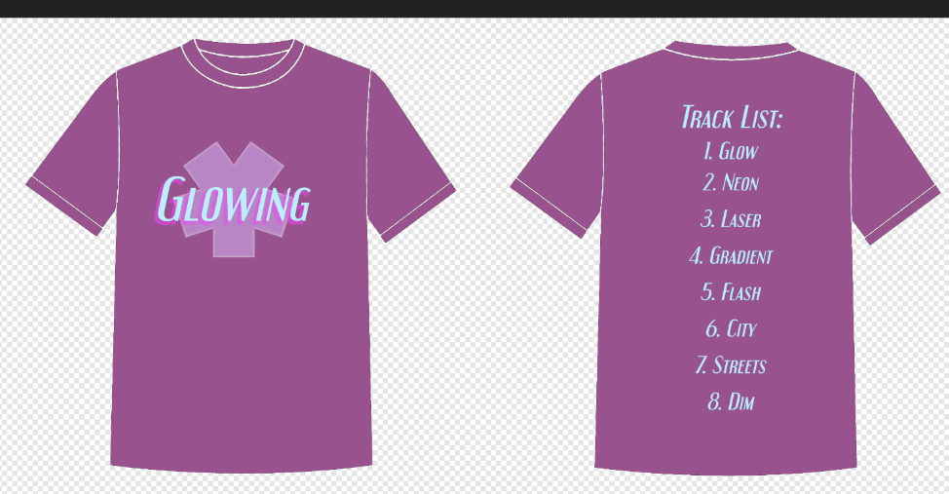
Figure 88 - Proprietary T-Shirt Design Step 4
The T-shirt design is now complete.

T-Shirt Design (Open Source):
Find a T-Shirt Design template online, preferably one with clear copyright. Using the fuzzy select tool (set roughly to 35 Threshold), select every part of both sides of the t-shirt. Copy and Paste this into a new layer. Delete the background layer.
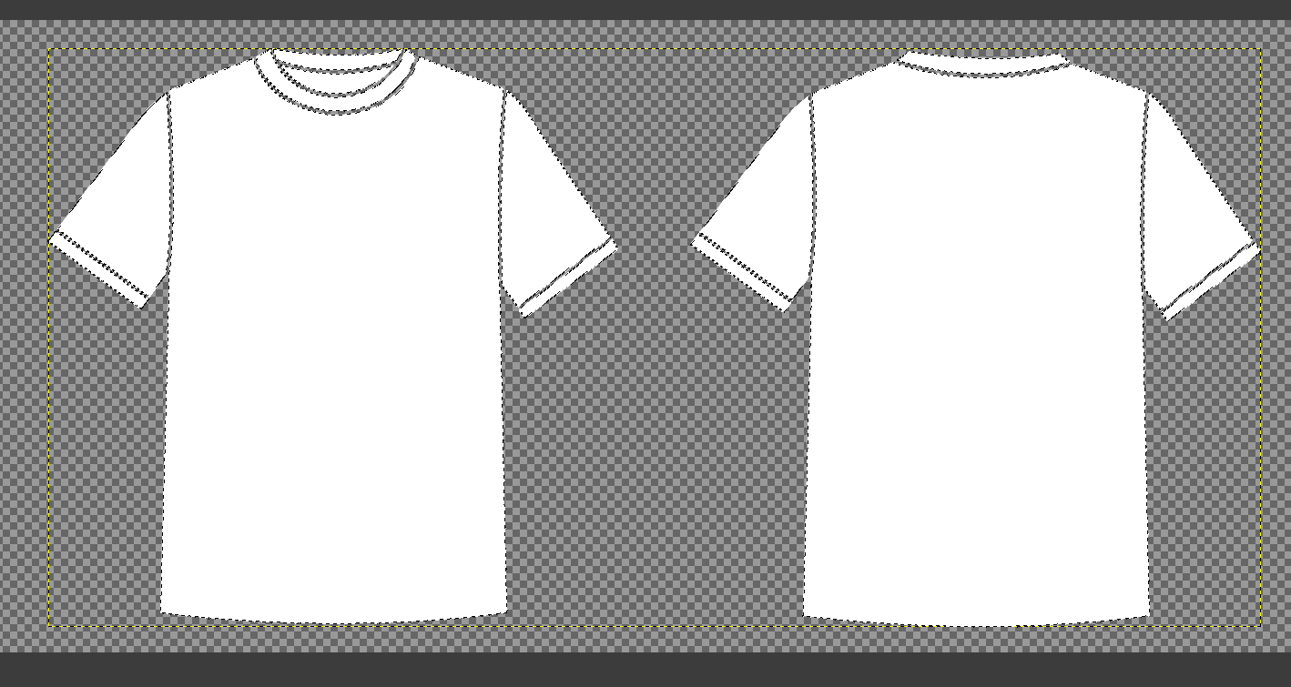
Figure 89 - Open Source T-Shirt Design Step 1
Set the primary colour to Hex #9D4990 and use the fill tool to fill in the entire t-shirt.
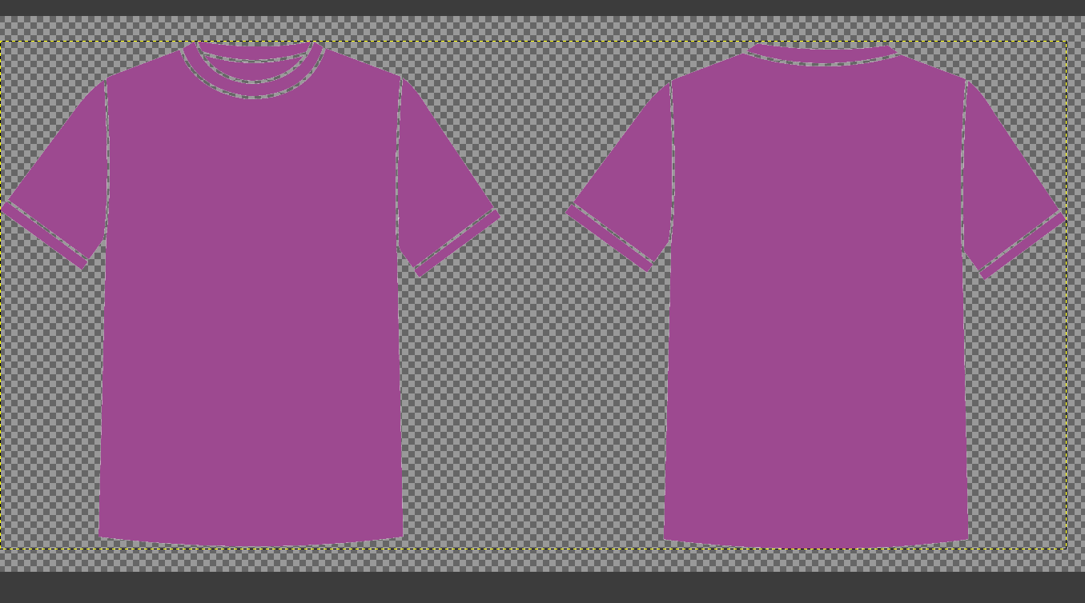
Figure 90 - Open Source T-Shirt Design Step 2
Open the Digital Album Design File and Copy and Paste the Square Star and Logo into the project. Rasterise the layers and place them on the front of the t-shirt.
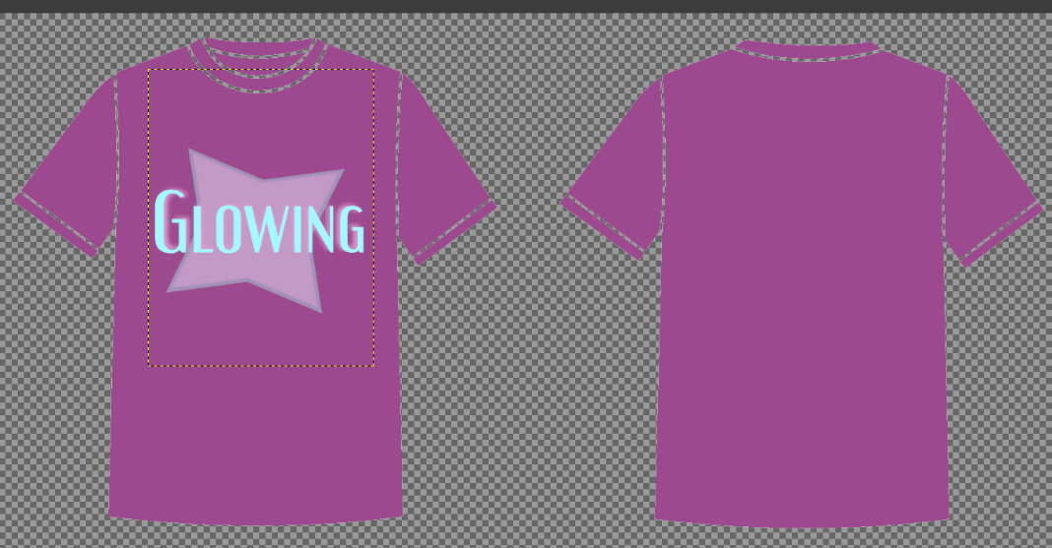
Figure 91 - Open Source T-Shirt Design Step 3
Open the Track List design file and copy and paste the Track List text into the project, placing it on the back of the t-shirt.
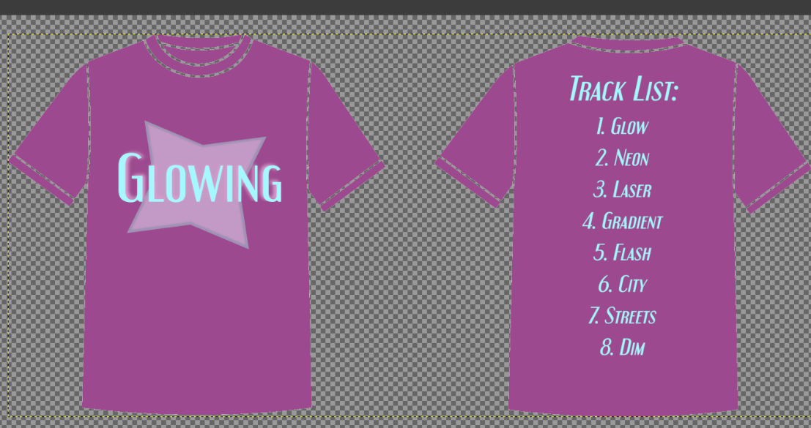
Figure 92 - Open Source T-Shirt Design Step 4
The T-Shirt design is now finished.

UV Mapping (Proprietary - MAYA):
(Note: Due to issues with texture mapping, the Box Model has had to be remade in a simpler form. The below manual will start with the instructions to making this box model.)
In Maya, create a new Cube. Using the scale tool, make it longer than it is wide.
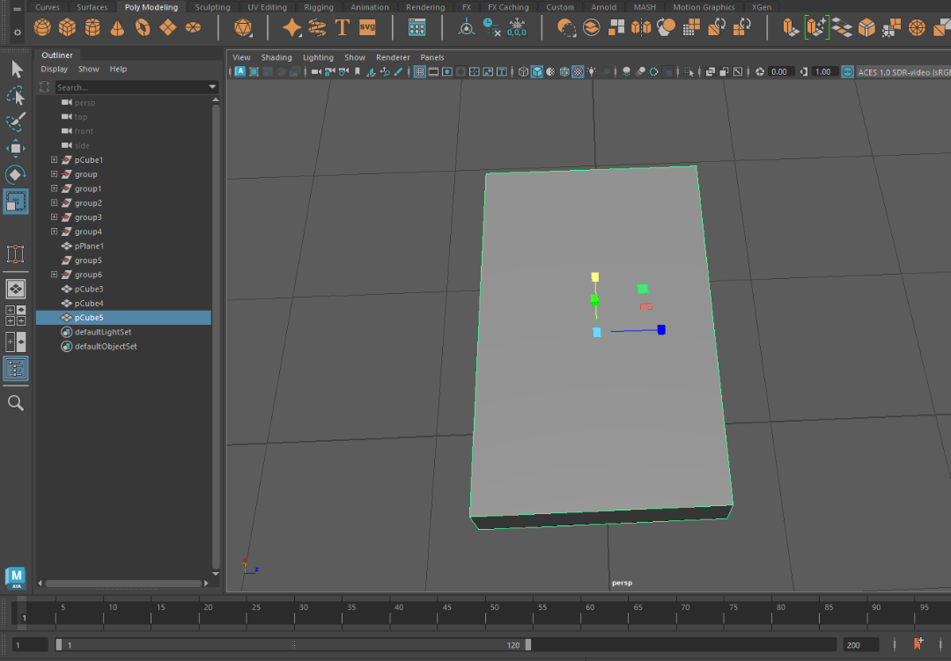
Copy and paste this cube, move it slightly below the first cube, and make it slightly smaller.
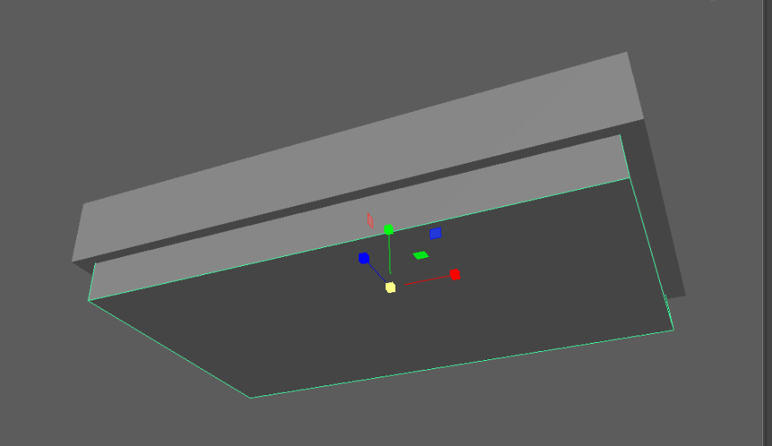
Separate the two cubes. Change to face select mode, select the bottom side of the larger box and push delete. Do the same for the top side of the smaller cube.
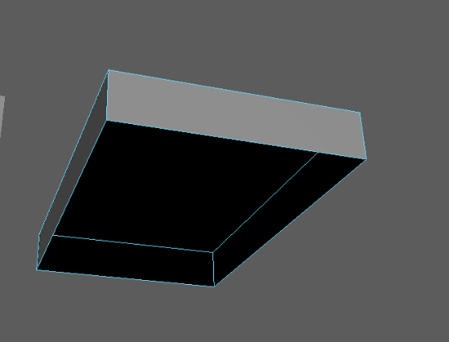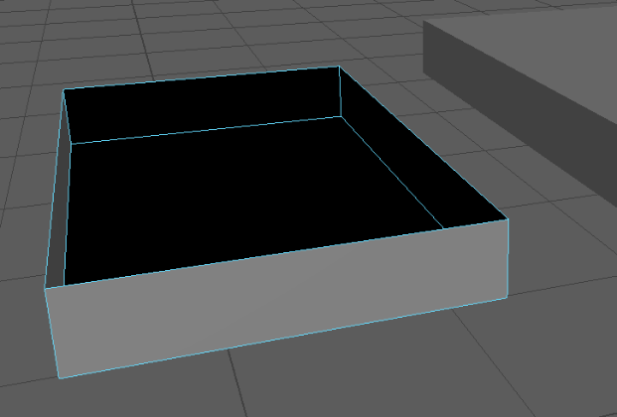
Open the Hypershade window and make a new Blinn texture.
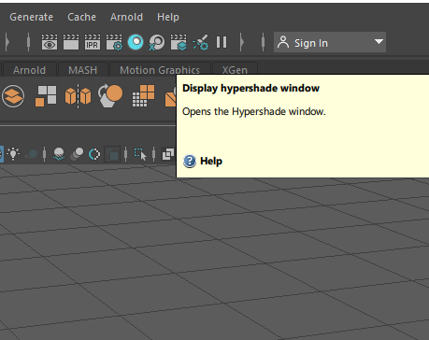
Click the checkered logo beside Colour and select File.
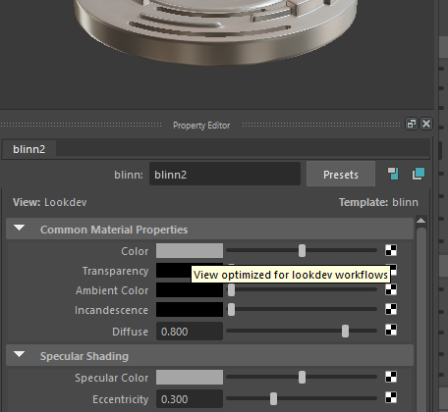
Click the folder icon beside Image Name and select the Top Box texture.
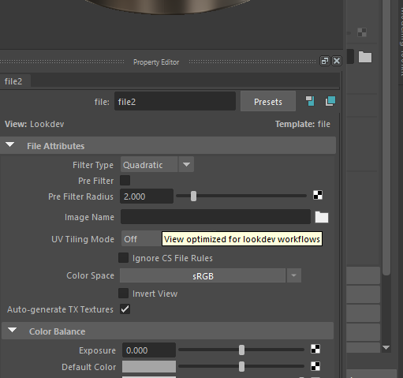
Click on the larger box, then hold right mouse button on the new texture and select “Assign Material To Selection”
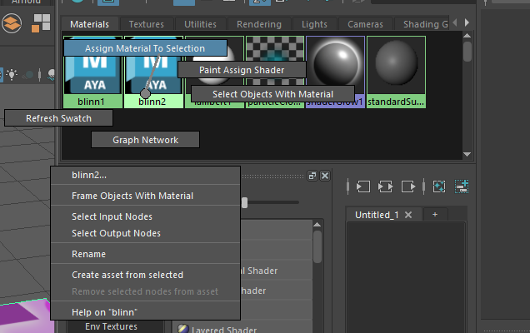
Repeat the same steps and apply the Bottom Box texture to the smaller Cube.

Click on the top box and go to UV UV Editor.
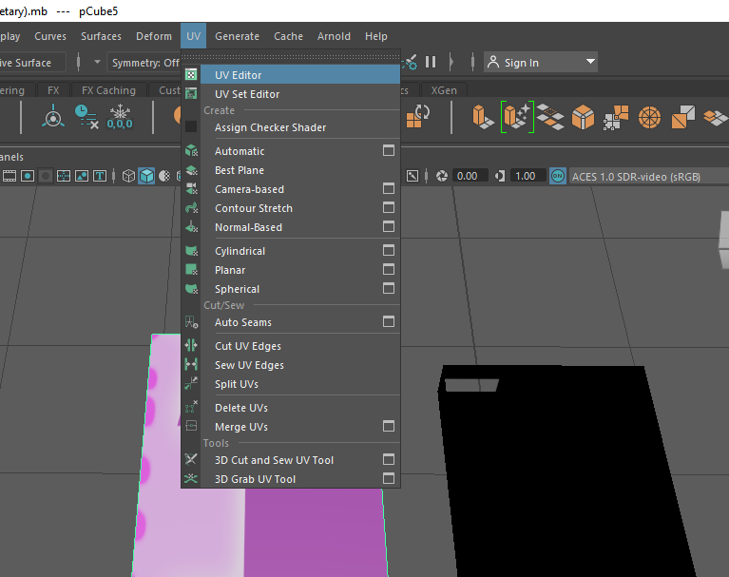
In the UV Toolkit, open the Unfold sub menu and click “Unfold”.
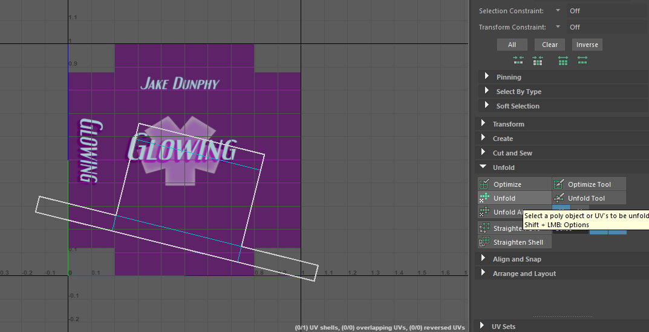
Open the Cut and Sew submenu, select all inner edge of the box and click Cut. This will allow you to move each part of the UV independently.
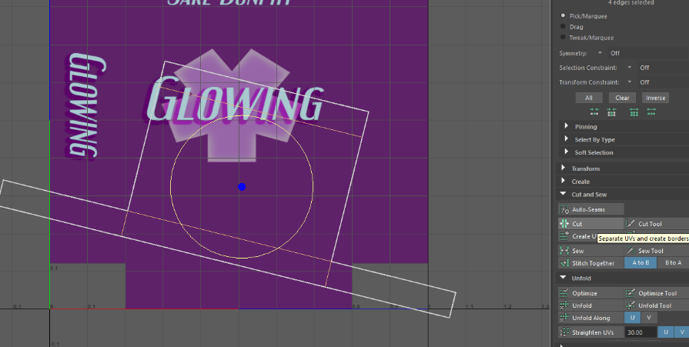
Using the move, scale and rotate tools, arrange the UV so it looks like the following.
(Note: The UV Shell might be rotated incorrect initially. Make sure to check the box regularly as you are working.)
(Note 2: The edges will likely need to be sewn back together once they are arranged correctly)
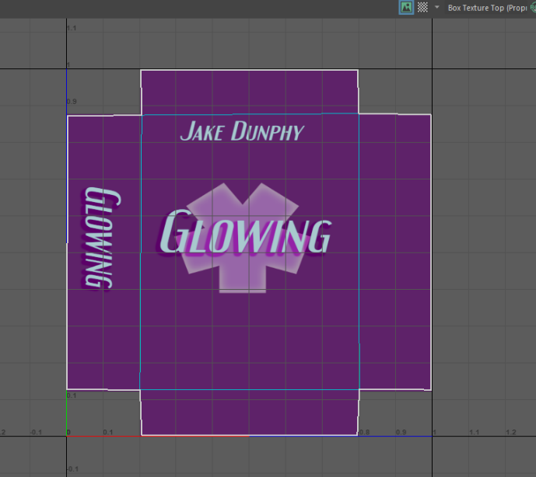
Repeat the same process for the bottom box.
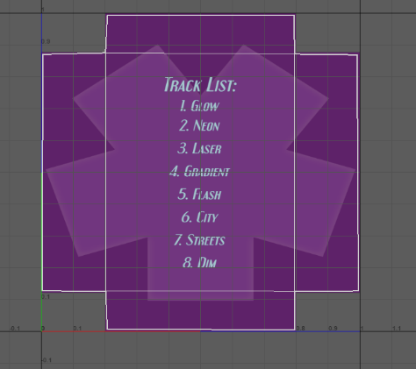
The box has now been UV Mapped.
The poster design can be applied to the poster, and should match up well without needing to be modified.

Promotional Video (Proprietary – MAYA)
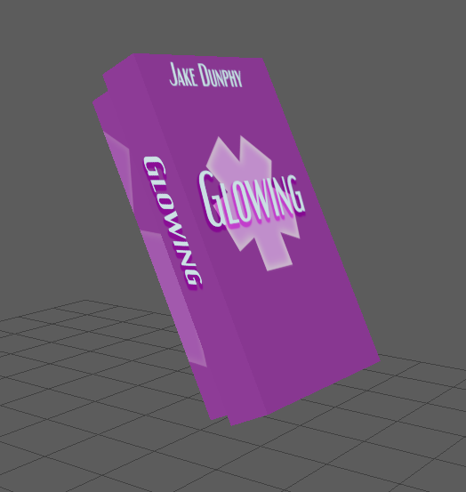
Arrange the box like with, with the poster sitting inside.

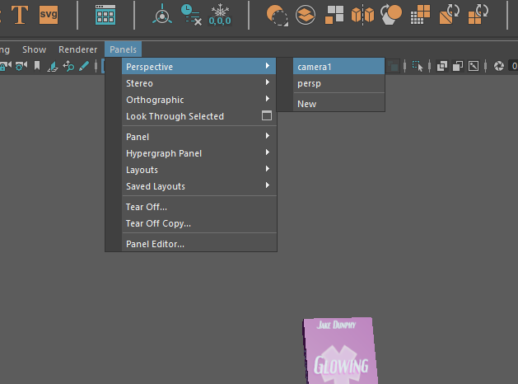
In the viewport, go to Panels Perspective select your new camera.
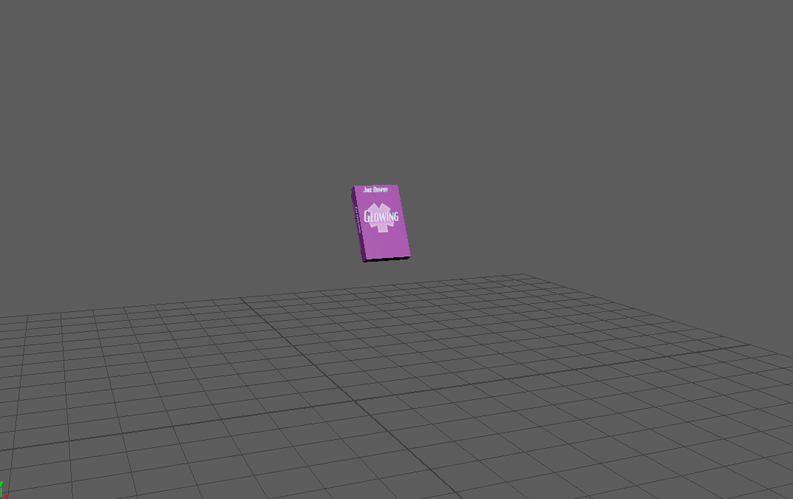
Place the camera far away as above.
In the timeline at the bottom, click on the first frame and push S to add a keyframe.
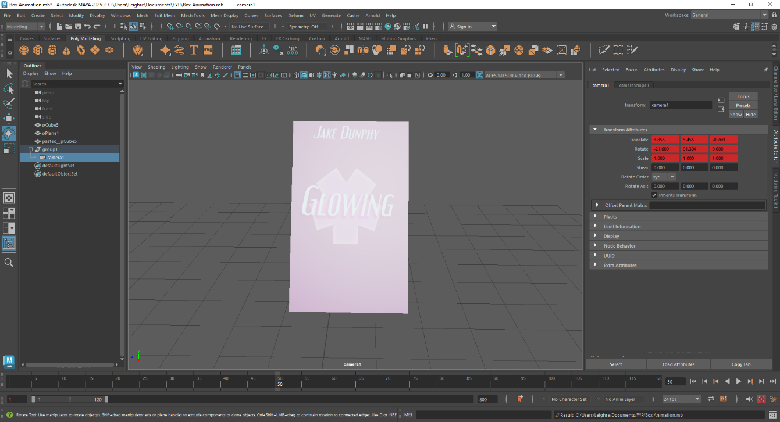
Make another keyframe at Frame 50, and then move the camera to this position.
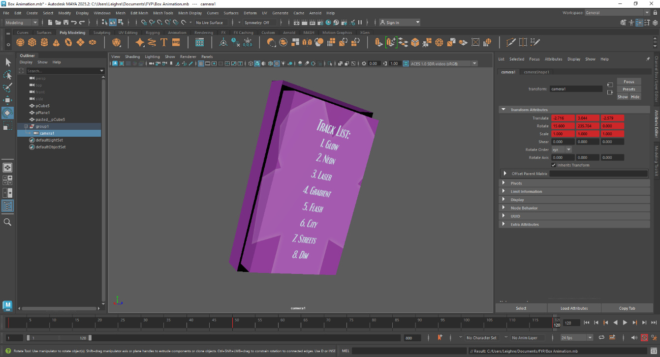
Make another keyframe at 120 and move the camera to this position.
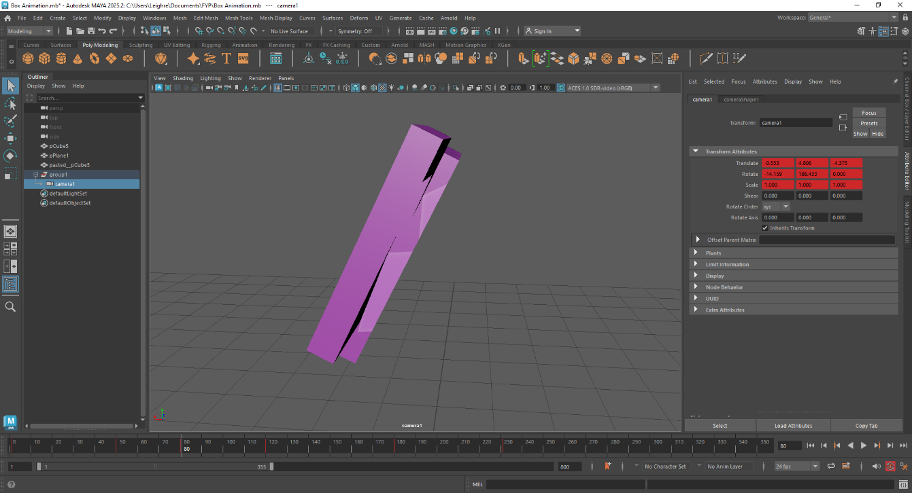Make another keyframe at 80 and move the camera to this position. This is to stop the camera going too close to the box.
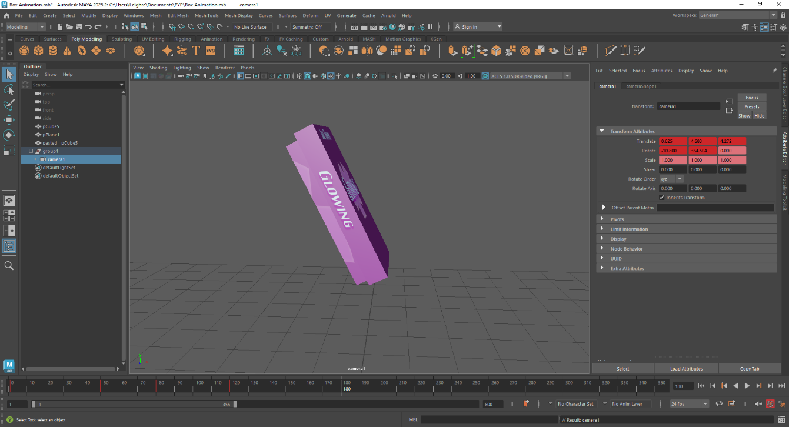
Make another keyframe at 180 and move the camera to this position.
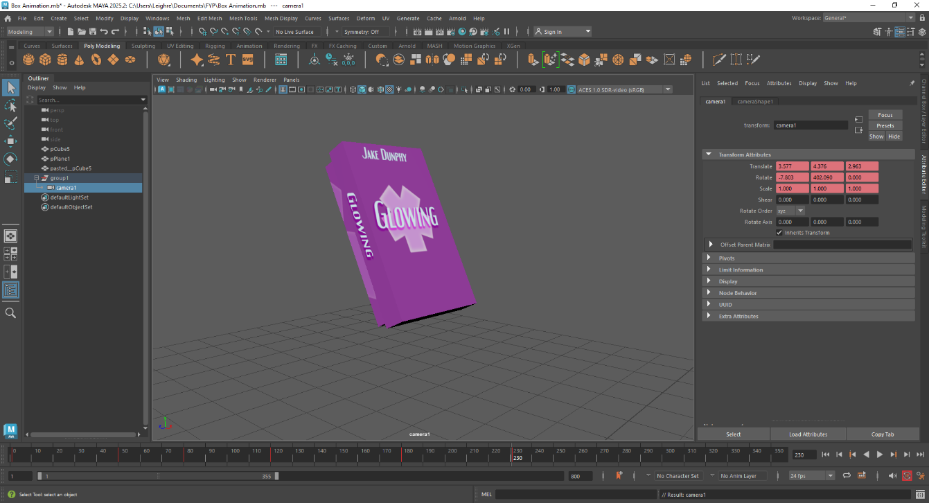
Make another keyframe at 230 and move the camera to this position.
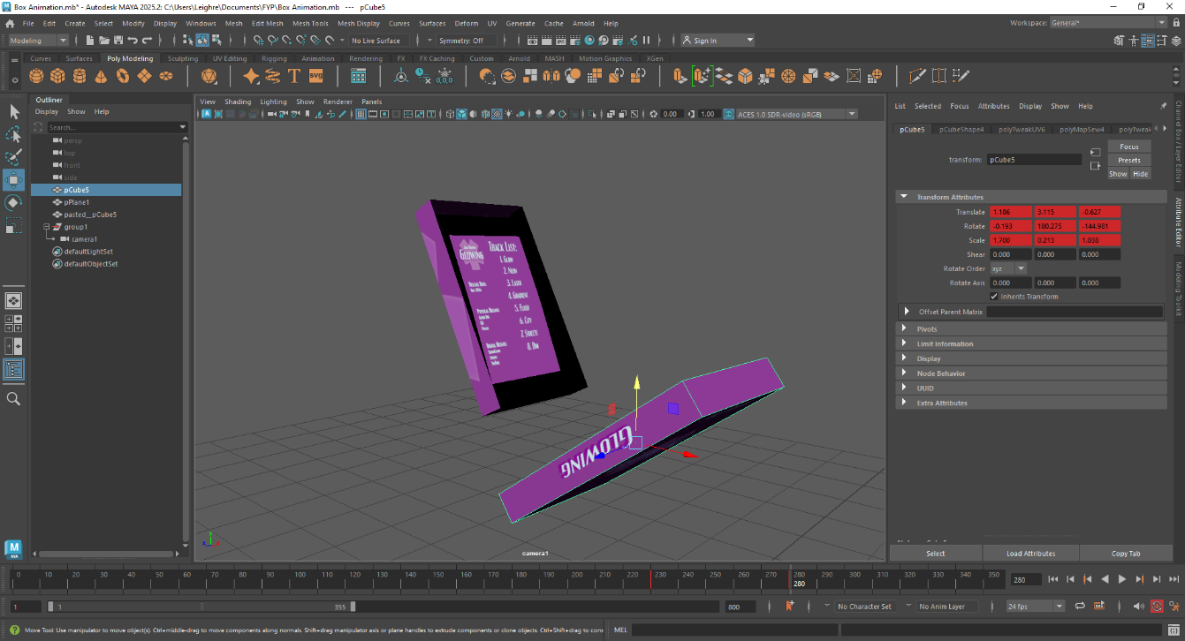
Select the top box, make a keyframe at 230 and at 280, then move the box to this position.
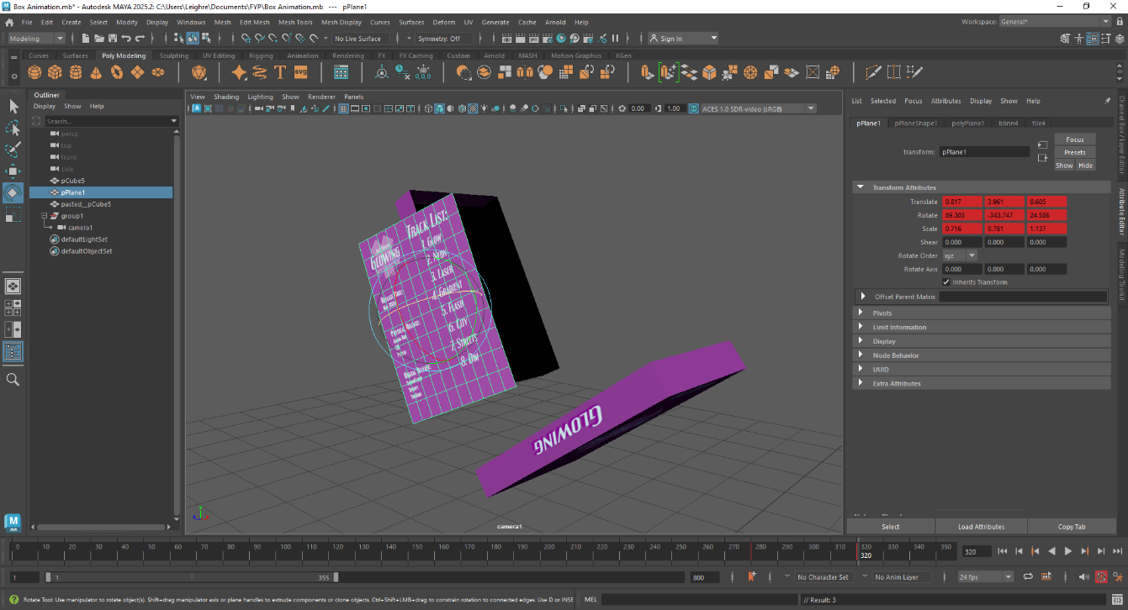
Select the poster, make a keyframe at 280 and at 320, then move the poster to this position.
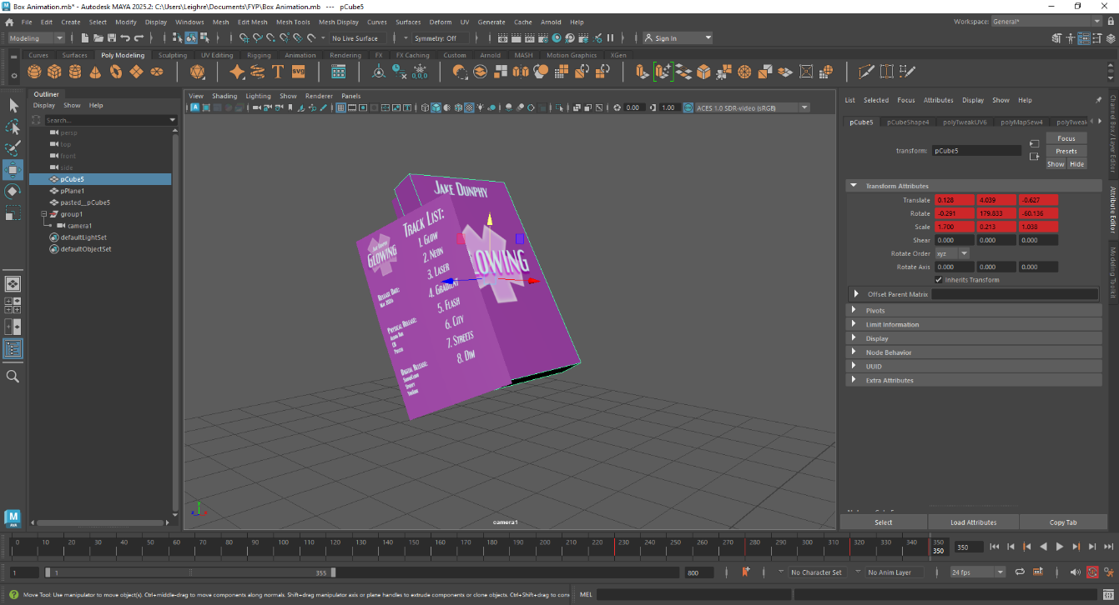
Select the top box again, make a keyframe at 320 and at 350, the put the top box back where it was. (Note: if the camera needs to be moved to see the box, make sure to change the perspective back to the “persp” camera in order to avoid moving the scene camera.)
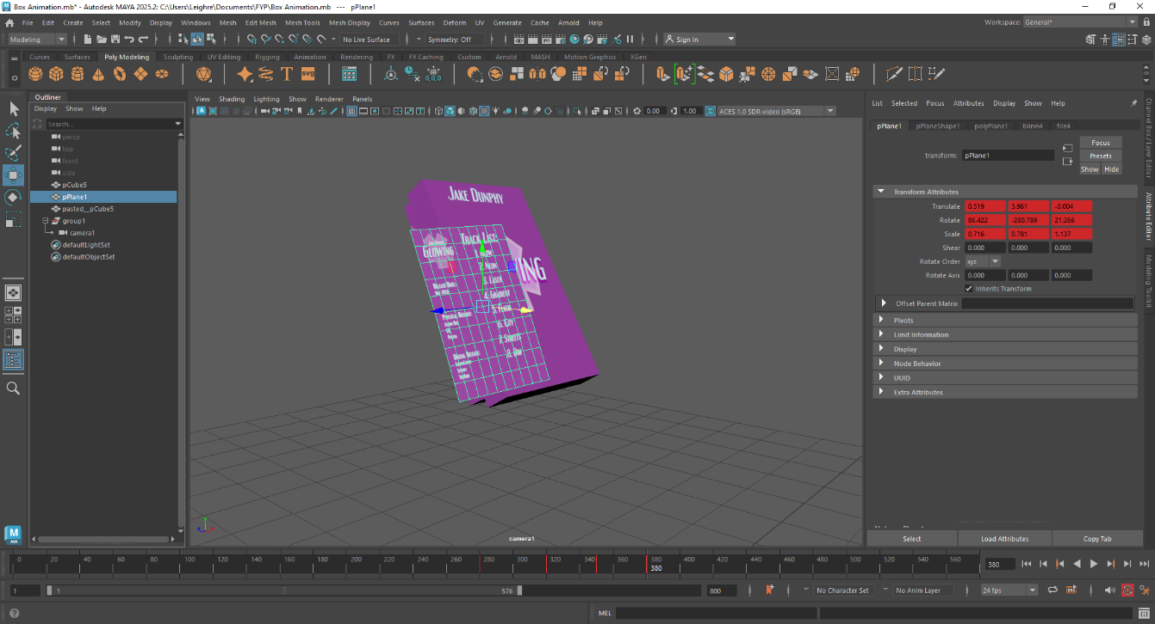
Select the poster again, make keyframes at 350 and 380 and move the poster to this position.
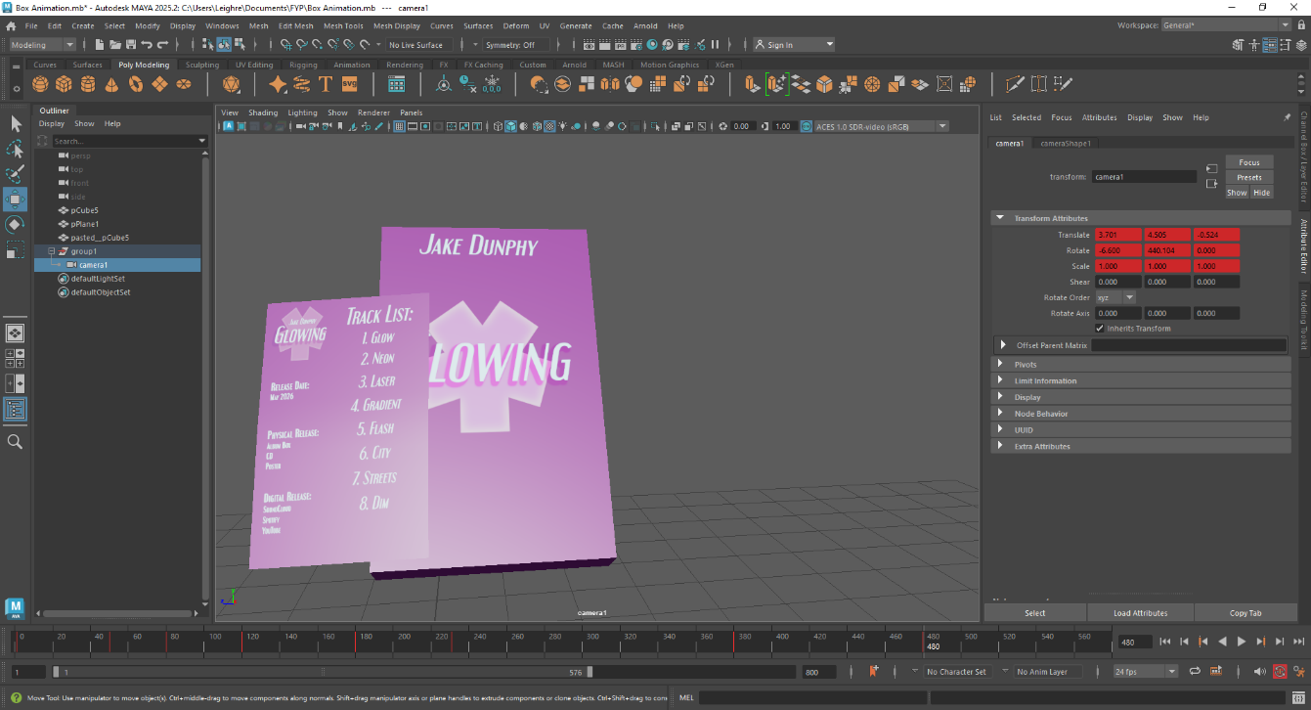
Select the camera, make keyframes at 380 and 480 and move the camera to this position.
Switch to the Persp camera view, as no more camera frames are being added to the scene.
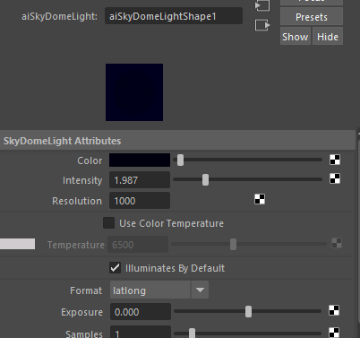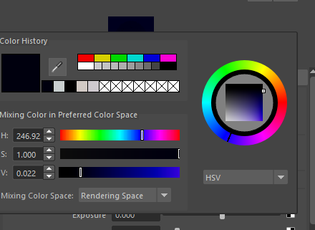
Create an Arnold Skydome light with the above settings and colour.
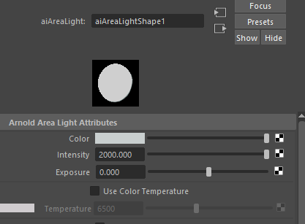
Create an Arnold Area light with the above settings and place in the following position.
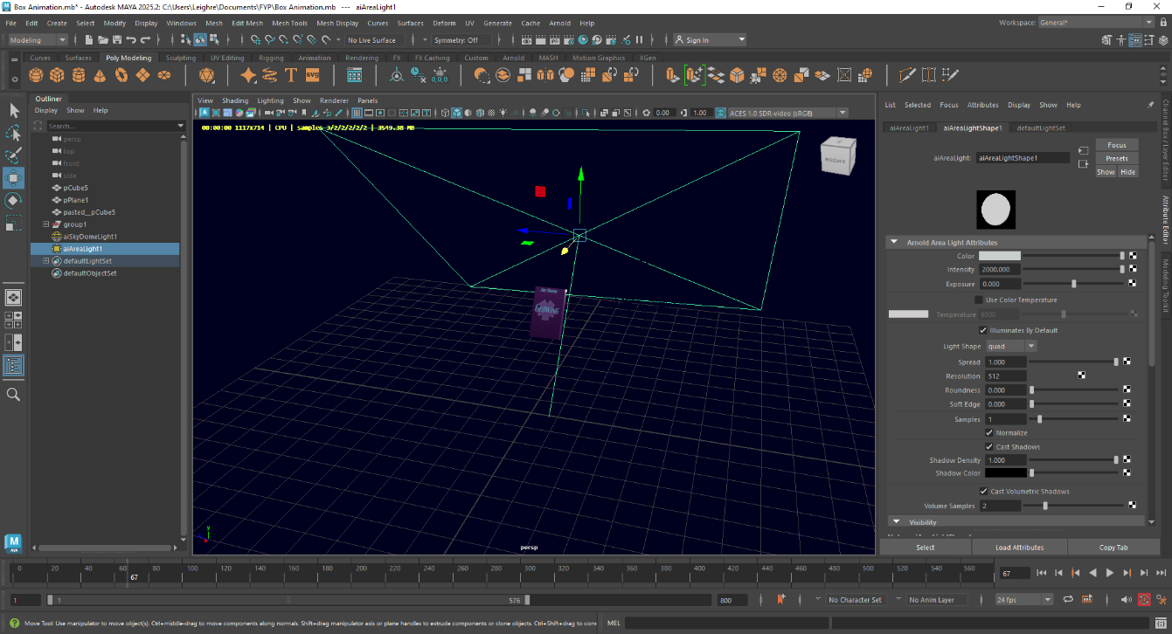
The animation is now complete.
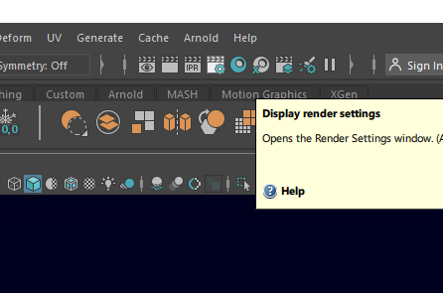
Go to display render settings. Set the Preset to HD_1080 and change the image type to PNG. Set the ending frame to 560.

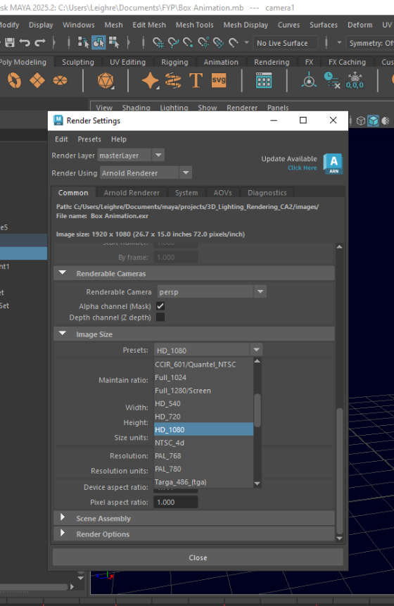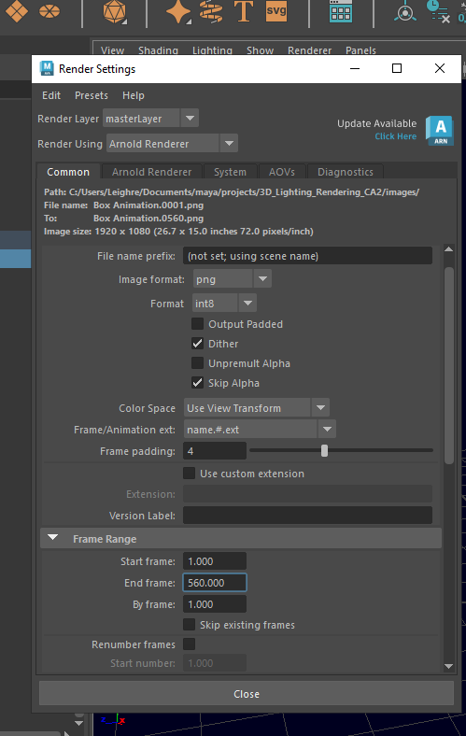
Change the tab mode to Rendering, then go to Render Click the box next to Render Sequence.
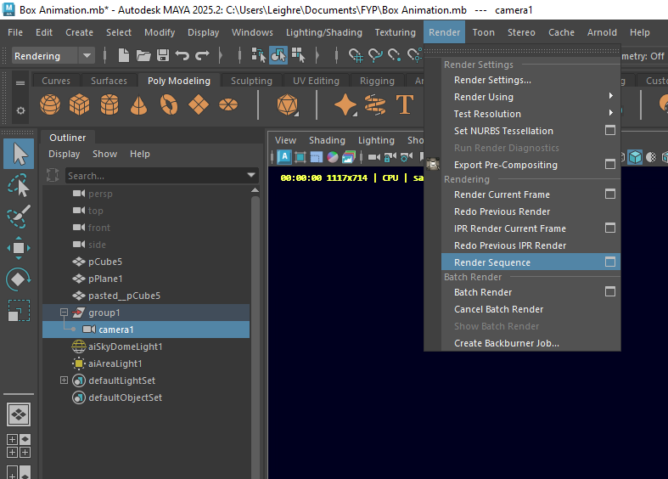
Make sure the camera is set to Camera 1, then click Render Sequence and close.
